Jahia Book
Chapter 2 - Quickstart

Jahia
9 route des Jeunes, CH-1227, Carouge Switzerland
http://www.jahia.com > The company web site http://www.jahia.net > The community web site

Version
This table records the versions of this document and their last updates
Version | Author | Date | Modifications
1.0 | Jonathan Coates | 2008-03-19 | Initial document
1.1 | Stéphanie Rouaud | 2008-07-11 | Add missing chapter

Summary
Page
Version 2
Summary 3
Advanced For All 4
Administration mode 4
How it works 6
Author role 11
Edit mode 11
Preview and Compare mode 40
Workflow 42
Manager role 48
Managing users rights 48
Managing publication workflow 57
Managing archived Versions 65
Import / Export 72
Managing Logs 73
Site Administrator Role 75
Site Settings 75
Server settings 107
Managing the jahia sites 126
Site Settings 126
Server settings 158

Advanced For All
This chapter describes the administration panel.

Administration mode
As soon as you are identified by the system, Jahia will display you a top bar Menu to access to the administration mode.

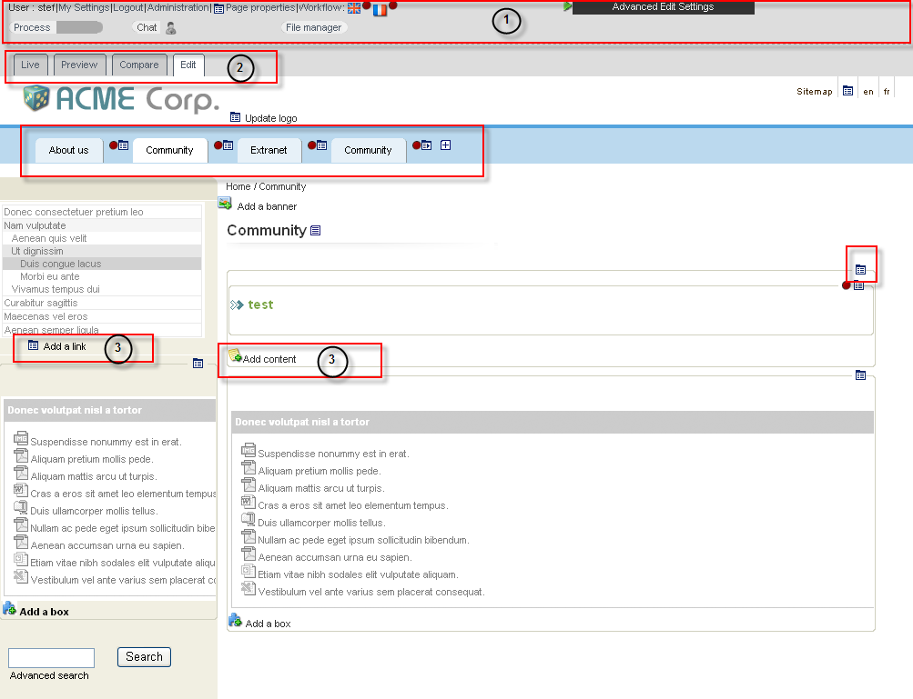

Figure 4-1: Administration panel

The administration panel is divided into 3 mains areas:
The top navigation bar (1)
The tab bar which allows you to navigate into the different mode (2)
The link and icons to add content (3)
1.1 Top navigation

In this section you will have access to the administration features depending on your access rights.

Figure 4-2: Jahia TopBar- read permission

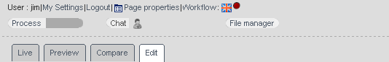

Figure 4-3: Jahia TopBar - write permission

Figure 4-4: Jahia TopBar – Site Administrator

You may now access to several new information and functions:
Your ID so that you know which user is currently active (for example if you have several logins)
If you have only Read permission, you will not be able to access these features (Author and Manager only):
Your settings, you will be able to update your personal information.
The tabulations to switch to another Mode (Preview, Compared or Edit).
A list of all the available languages
The Workflow icon
The Administration Center Menu (only for Site Administrators).
The Advanced Edit Settings (only for Site Administrators).
A Chat icon, which allows you to discuss with another user logged in the administration tools
And a File manager to easily add and shared various file in the system.

How it works
2.1 icons and general description of the edit page

JAHIA has a set of simple functions, allowing anyone to create and manage the various objects of content (e.g. a page, a field or a portlet).
To access the edition function, just click on the Edit Mode tab on a page where you have the right permission. Several edition icons will appear and will allow you to edit and modify the various content objects.
You can now click on the key editing features (small edition icons - just roll-over the mouse on top of them to know their function). In the Jahia 5.0 corporate portal template, the icons are grouped together in a drop down menu like this:

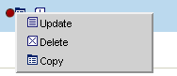

Figure 4-5: Edit Icons

Please find a short summary of these icons below:

1. Object properties icon

Figure 4-6: Object properties icon
Allows you to display information regarding the current object, for example a page (access rights, template in use).
This icon is also used for the Copy and Paste functions.

2. New content icon
Figure 4-7: New content icon

A function at your disposal at any time to create a new web page or add a new content object.

3. Update icon
Figure 4-8: Update icon

The content of the current object will be displayed in a web form in order to be modified. You will then have to validate ("save") your changes once you are satisfied with your modifications. While you edit this content, no other author may edit it simultaneously. The Jahia locks are automatically managed by the system and prevents two users to modify the same content simultaneously
4. Delete icon

Figure 4-9: Delete icon
Allows you to remove already published information on a page and its sub- pages. The content is not definitively deleted from the database and may be restored afterwards if required (cf. versioning section).

 Be aware that when you delete a page, you will also delete all the sub-pages.

In each of this engine, you will find the same navigation arrow as presented below:

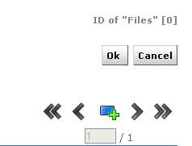

Figure 4-10: Arrow navigation

So you will be able to create several content object directly with the  add button and navigate through them with the arrows.

You could go directly to the first or the last content object with the double arrows.

2.2 The Jahia Edition Pop-up Windows Mechanism

Jahia is based on a simple visual editing system based on pop-up windows. Each time you click on an icon, a pop-up window will appear and will let you manage the related content object. As soon as the modifications are done and saved, the Author may immediately see the result on his web page.

Each edition pop-up is structured in the same manner:
A top bar with various possible operations
The languages available
A left bar with the fields available
A central part to edit the content
According to your rights, you may either access:
Data
Edit the content. Only this tab is available for Authors. All the other tabs can be only accessed by the Content Manager.

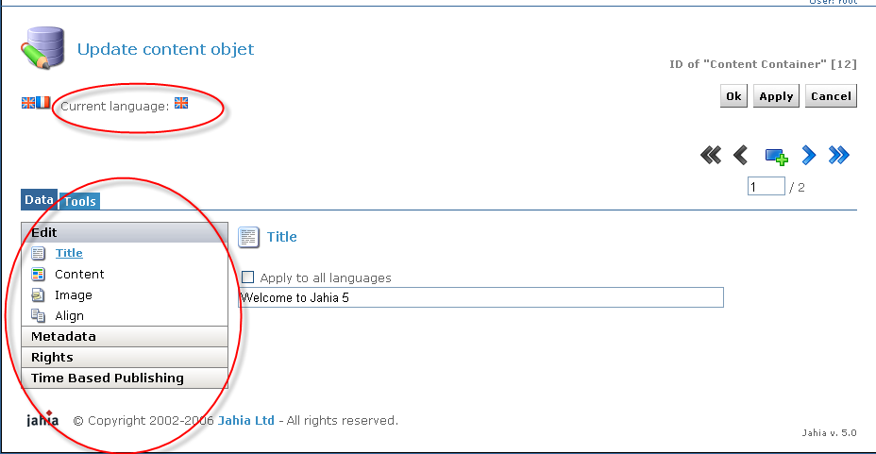

Figure 4-11: Data interface options

Tools
The manager can set the publication workflow, the versioning or access the object's log file that provides information on any actions executed on the object.

2.3 Lock-in / Lock-out principle

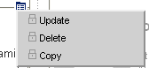

Figure 4-12: Lock icons

If another Author is already editing an content object, lock icons will appear in Edit mode around the object. While the other Author is editing, you can not modify the content. This prevents the overwriting of two modified content submitted simultaneously to the database. Only one author may edit a field at the same time.
By clicking on the lock icon, you may see who is currently editing the content object.
All the content elements on a page are also locked-in if they are under validation. This prevents an Author to request for a validation and a few minutes later another Author begin modifying all the texts. So as soon as a page is under validation, no author may edit it any more.

Author role
This chapter describes all the action an author can make.

Edit mode
1.1 Edit Mode Panel

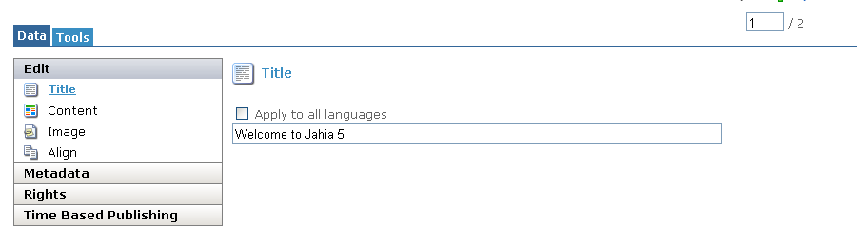

Figure 5-1: Edit mode panel- Data tab

In the Data Tab, you have 4 sections:
Edit, which contains the fields define in the template to caracterize the object
Metadata, to categorize the object and easily retrieve it in a search
Rights, to define the permissions (for manager only)
Time Based Publishing, to schedule a specific publishing time frame

1.2 Managing field

Let's start with the edition of basic objects of content.
Jahia has currently 11 types of fields:

- Small Texts: Texts that have less than 250 characters
- Big Texts: Long texts with an unlimited number of characters. The Big Texts can be edited with one of the WYSIWYG editors installed with Jahia to ease content input.
- Integer: any integer number
- Float: any number
- Boolean: True of False
- Link Field: URL link
- File Field: Link to an uploaded file
- Color: a color picker
- Date Field: a date picker
- Application: Embed a web application (portlet) in your page at the current position
- Page: a new Jahia page. Check following chapter to know more about managing pages

 Apply to all language option
The Apply to all language checkbox lets you copy the current content of a field to all the other languages. This may be useful when you want to avoid copy-pasting content that is similar in all languages

Small Text
The small text field is usually the most commonly used in Jahia. It is limited to 250 characters.
Text fields support HTML code. Here is an example:
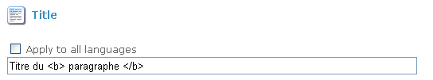

Figure 5-2: HTML supported in small text field

Type in the HTML code above and click OK.

 If an HTML tag is missing or incorrect, you will not be able to save it. Clicking on OK will not allow you to close the window.

Jahia supports Unicode set of characters and if your Jahia Site Administrator has installed this extension, you may also enter extended set of characters (Cyrillic, Greek, Japanese…).

Big Text field
The Big Text is similar to the Small Text field, except that there is no limitation in size.
Big Texts can be edited with one of the HTML WYSIWYG editors provided by Jahia. Additional third party commercial WYSIWYG editors may be installed and configured specifically for Jahia on a case per case basis.
By default Jahia is provided with two editors for big texts:
The standard text based editor (HTML text mode editing)
An HTML WYSIWYG Editor – FCK Editor

The RealObjects editOn pro Commercial WYSIYWG Editor (Mac, Unix and Windows, IE and Netscape) can also be used to edit Big Text fields. (more information about editOn Pro on www.realobjects.com).

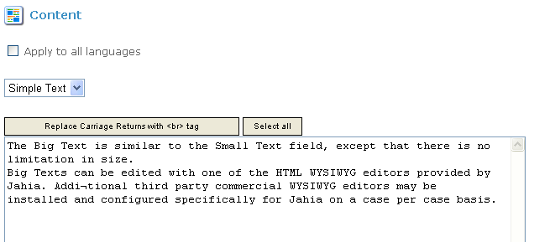
Figure 5-3: Big text field in text editor

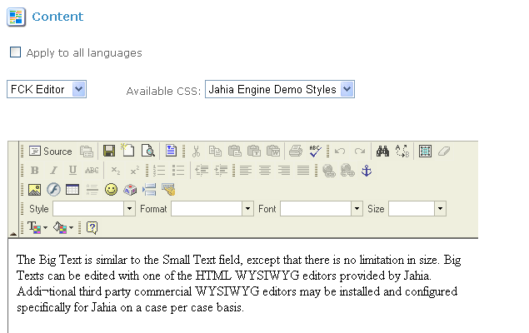

Figure 5-4: Big text field in the FCK Editor

More details on the FCK Editor

If an HTML tag is missing or incorrect, you will not be able to save it. Clicking on OK will not allow you to close the window.

Integer Field
The Integer Field lets you input a round number.

Float Field
The Float Field lets you input any number.

Boolean Field
The Boolean Field lets you select between the values True and False.

Link Field
Links Field leads you to another page or website. You have two types of links in Jahia:
Internal Links: cross-links towards another Jahia page
Remote Links: links towards an external web site

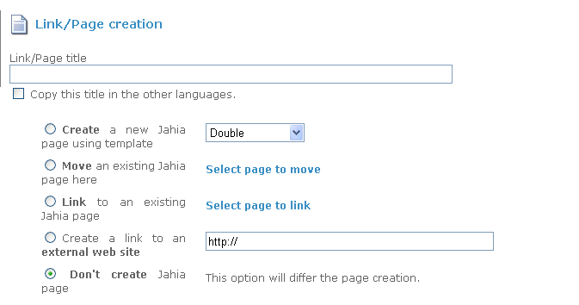

Figure 5-5: Link Field

Internal links are controlled by Jahia. If the page is removed, the link field will also disappear to avoid any broken links. This control is not done for remote links.

File Field
Various office documents, pdf's etc… can be made available to users for download.
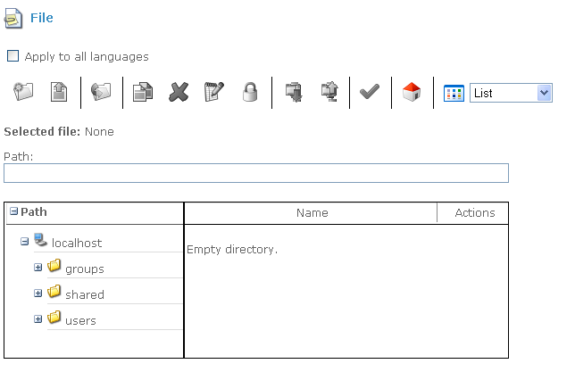
Figure 5-6: File Field

Jahia provides a simple mechanism to upload files on the server.
You will find more information in the file manager section

Color Field
The Color Field lets you choose a color thanks to a color picker .

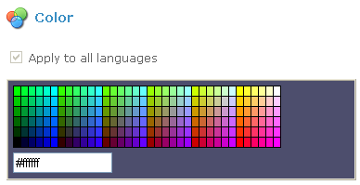

Figure 5-7: Color Field

Date Field
The Date Field allows you to easily enter a date.

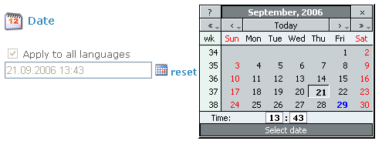

Figure 5-8: Date Field

The date field is stored in the database as a date. Then your template developer may customize the display of the date according to what he wants to show.

Application Field
The Application field lets you select and embed a portlet inside your page. A Portlet is a dynamic field that will contain some business logic. This field will be automatically executed when you launch the page. This field is the base field for all the Corporate Portal part of Jahia to construct MyYahoo like home pages.

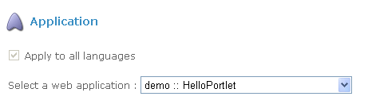
Figure 5-9: Application Field

Check the Managing Portlets Section to know more about it.

Page Field
New Pages are also considered into Jahia as a type of field. Please check the “Managing Pages” section to know more about it.

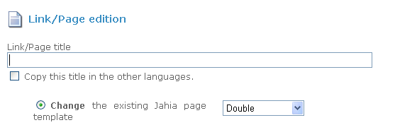

Figure 5-10: Page Field

Shared Field
The template developer may decide that a certain field is shared between all the languages. Then you will only have one content for all the different languages (e.g. Name, ZIP code, ...).

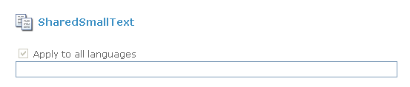

Figure 5-11: Shared Field

You have to be aware that when you modify such a field, all the languages will be impacted. The effect is that the status bar in all the languages will turned to red at the same time. It is the same if you validate such a content in only one language. As it is a shared field, all the other languages will be also validated. You can not have a desynchronized status (one language in draft mode while the other is live mode for this kind of fields).

1.3 Managing Grouped Fields: Container and ContainerList

The JAHIA Containers enables you to add grouped elements (set of several fields grouped together). This is what we call a container in Jahia.
This is usually the most common way to use Jahia as most of the times; one field is not enough to create a pertinent content object (e.g. an object news or an address).

So the web designers, during the development of the templates, may decide to group together several jahia fields (cf. list above) into one container.
To edit a container, simply click on the container icon. You will see an edition pop-up that regrouped all the fields to edit at the same time.

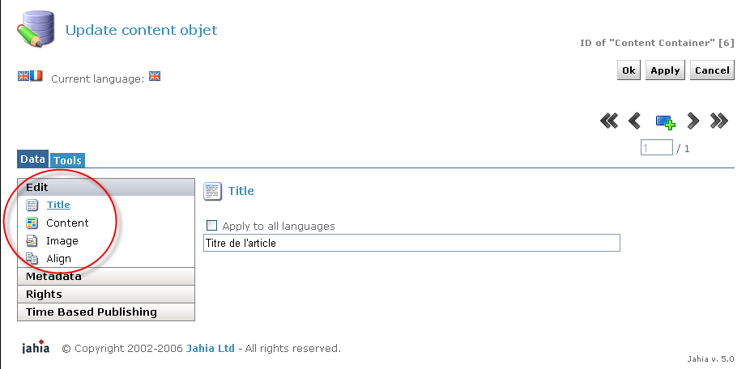
Figure 5-12: Container Field

It is not mandatory to fulfill all the fields. Certain fields may be left blank and will simply not appear on the page. Other fields may be used as meta-data and may also not appear on the web page because they will be used later on for other purposes (an expiration date for example).

Fields regroupment in a container
Certain fields may be regrouped together in one web page (e.g. all the “small text” fields).

This simplifies the input of data and avoids useless clicks to move between all the fields in the container. Certain fields may not be regrouped because they need a specific editor (e.g. a big text).
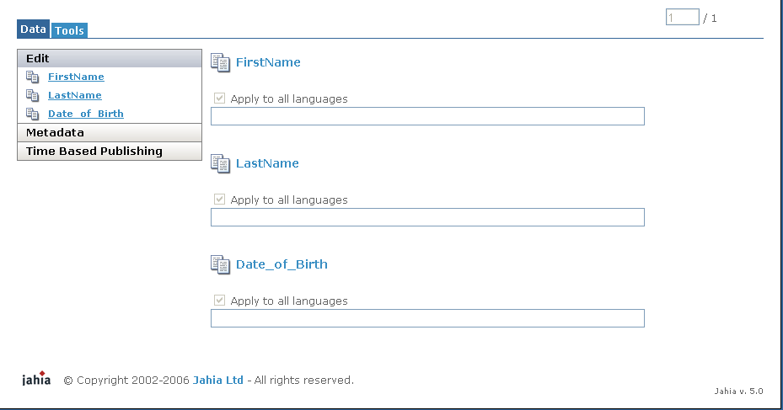

Figure 5-13: Add new container

ContainerList
Once the container is created, you often want to repeat it on a page (there is usually more than one address or one news). This is what we called a ContainerList in Jahia: a list of the abstracted content objects your webdesigner has defined. They are usually placed one after the other on a web page.

Click on the add button to add a new container to your list.

Keyboard shortcuts can be used to ease input of content:

• Ctrl+Tab: scroll down through all fields of a container
• Ctrl+Enter:: Submit the content and close the window (equivalent to clicking OK)
• Ctrl+M: Save and Add New
• Ctrl+W : Cancel

List Container
When you have several containers, you often want to be able to sort them in a given order. To perform this operation, you can click on the List Properties icon in the bottom of your list.
You can then choose the filtering key (the field on which you want to perform your sort) and the type of sort you want to apply (ascending, descending,...). You may also decide to perform a manual sort (you select yourself the order of the various elements of the list).

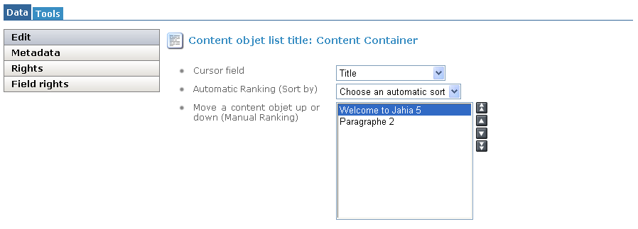

Figure 5-14: Add new container

1.4 Managing Absolute Fields

All the fields are by default relative to a page. But your web designer may have decided to share some fields on several pages (e.g. your page header or footer). This is known as Absolute Fields in Jahia (in opposite to a Page Relative Field).

You can edit such fields in the exact same manner as other fields. However your changes will impact several pages at once.

Absolute Fields Validation
You can modify an absolute field indifferently on all the pages where it appears. However you can only validate an absolute field on its parent page. For example, footers and headers are usually defined in the home page of your site. So it is only when you approve the home page that changes will be impacted on your whole web site even if you have done the content modifications from another page.

This system was put in place to avoid having to re-validate the whole web site when you simply change a page footer.

1.5 Manage Portlets

A portlet is a way to embed a web application or a web service into Jahia through a single and common Web interface. This provides a standard and easy way to add new functions to your web site. This also open the door for integrating collaborative tools into some of your web pages (e.g. discussion forums, mailing lists,...). One of the main advantages of JAHIA pour sis that it natively supports standard java web applications (servlets) as portlets. You may then embed a web application in any area of your pages.
Jahia has also a specific tool to help users position by themselves their portlets on the screen without having to create a new template. This tool is called the Layout Manager and will be described later on in this section.

Insert a new Portlet with a web application
You may insert a new portlet in any page like any other type of content fields.

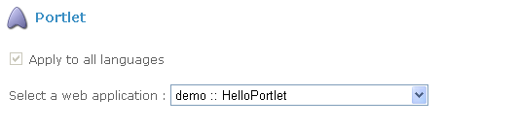

Figure 5-15: Add a portlet

For example, you may have, inside a container, an application field. If you select the application field, you will be able to choose which application you want to insert.

Role Mapping
Each web application may be setup with different roles. A Role gives you the right to access to different functions of a web application. While inserting a new portlet into a web page, you will have to map the roles of the web application to the existing users of your Jahia system. Once this mapping is done, each time the user will connect to the page, he will be automatically identified by the portlet in the correct role(s) (a user may cumulate several roles).
The same web application may be used on several web pages with different roles for the same users. For example, a user John may be able to access to some administrative role of a portlet in a certain part of the site but only act as a reader in another part.

Click on Manage to select which groups or users you want to assign to each of the application's role.
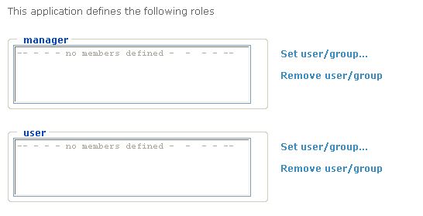

Figure 5-16: Manage role

Example of a portlet with an application:

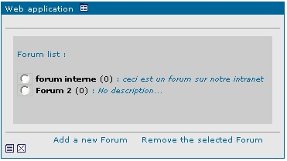

Figure 5-17 : Un portlet contenant une application de forum

The Portlet Layout Manager
The Layout Manager is a graphical interface customized in the template by the web developer that lets the users position and move by themselves the portlets on a page (or an area of a page).
To use the Layout Manager, proceed to the following:
Login into the portal
Switch to edit mode

You can now access the layout manager. Small arrows let you move portlets in your page.
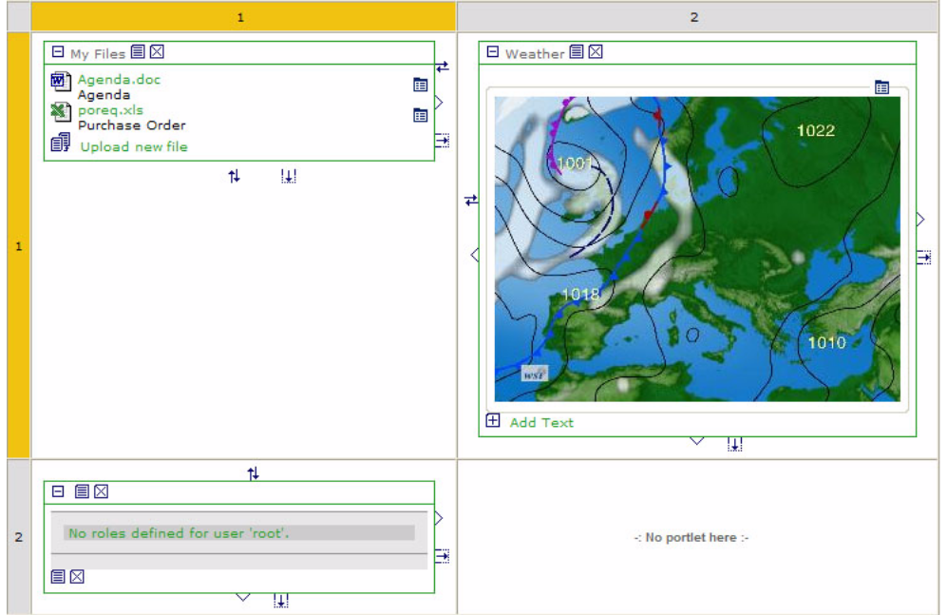

Figure 5-18: Layout manager

Default icons are the following. These icons may be replaced by your webdesigner. Check with your custom Jahia documentation if it the case.
Move Portlets

Swap Portlets

Increase Width

Increase Height


1.6 Managing Content in Several Languages

Jahia 5.0 supports multiple languages. Your Site Administrator may have customized the system from different manners that will impact afterwards your usage of Jahia.
You can see the various languages configured in your web site in the top bar menu.

Figure 5-19: Available languages

All languages are by default optional
If no language is set as mandatory in the system, Authors or Managers do not have to translate content and may choose to fill content in a given language only. This is the most common settings for Intranet or Extranet purposes. No verification check is done during the validation process and a page may only be partially translated or even not translated at all.

Some languages are mandatory, others are optional
The Site Administrator may decide that one or several languages are mandatory (e.g. English). So the Jahia system will force Authors to translate content before any possible validation. Such an option is useful for Internet web sites where you want to keep similar and homogeneous web sites available in several languages.

Languages mixing
The Site Administrator may decide to let the Jahia system mix languages on the same web page if certain objects of content are not translated.
For example, if you have a left column of text available in English but a right column only available in French and if you browse the site in English, by default you will not be able to see that there is a right column. You will have to switch to the French language to be able to display the untranslated information. However, you may want to manage some web sites, especially Intranets, where the Authors are not always forced to publish all their content.
So Jahia provides a mechanism to let the users see as much content as possible by following the order of their languages preferences. If the system detects that the right column was not translated, it will try to display it in the next language of preference of the current user (e.g. German), and so on until he can find the French content.

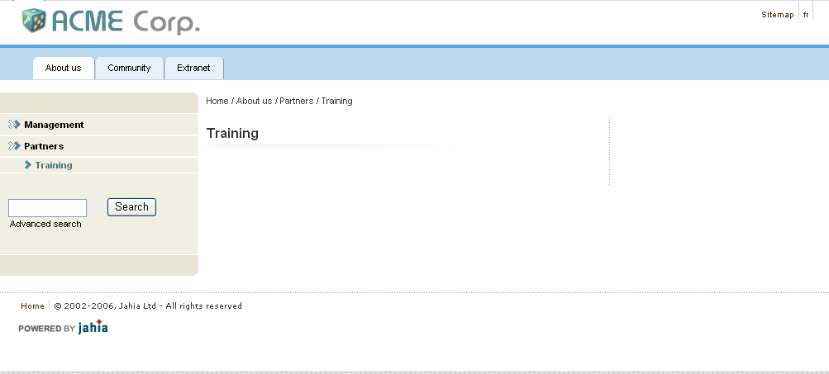

Figure 5-20: English page without content and option mix content not activate

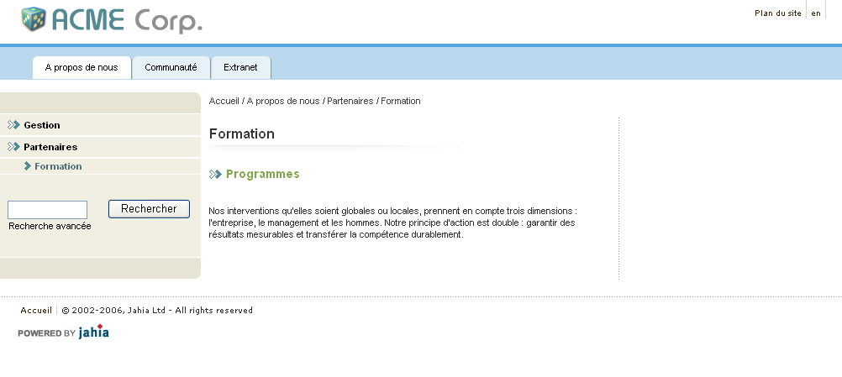

Figure 5-21: French page with content and option mix content not activate
Edit Mode
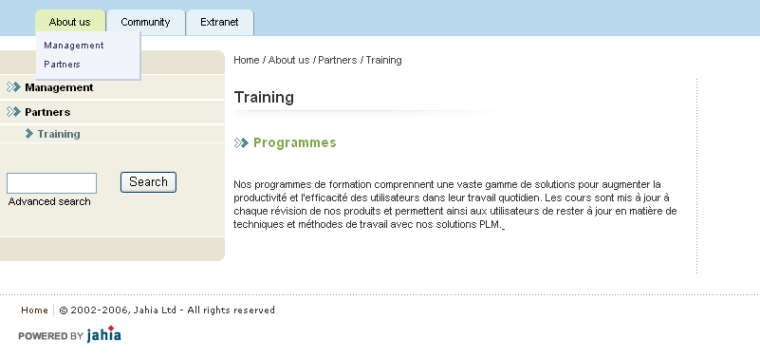
Figure 5-22: English page with French content due to the activation of the mix content option
(The French has been automatically placed by Jahia to fill the blank)

If you have setup a site with two mandatory languages but you want to create an exception (finally there will be a page that will be available only in one language), the Author may ask the site administer to temporarily deactivate the mandatory languages checking mechanism. The user can then validate his “one language only” page. The Administrator just needs to reactivate the mandatory language option afterwards.

Translation Field content
In all the Edition pop-ups, you will find the same topbar indicating all the available languages. Just click on a flag to access the fields in another language.

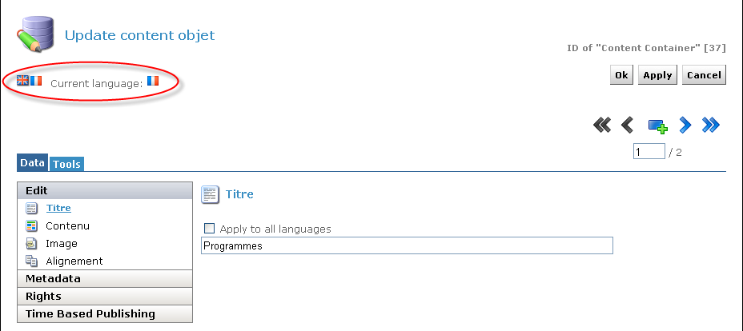
Figure 5-23: Available language

Shared Content Fields

Some Fields may be shared among the various languages and can not be different. For example the fields:
Integer, Float, Date, Color, Link will be similar for all the languages. So if you modify such a field in one language, all the other languages will be immediately impacted.

Language Checking during Validation Workflow
The Workflow will check for the mandatory languages and will verify the completeness of the translation(s) done (each field input in a certain language has to be completed in all the mandatory languages too).
To ease input and detection of missing fields in other mandatory languages, the Workflow offers an integrated diagnostic tool that will indicate to the Authors the list of uncompleted fields.

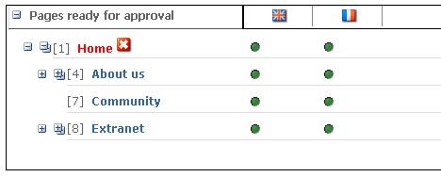

Figure 5-24: Workflow diagnostic

You just need to click on the red cross icon of the selected page and a popup will appear with the list of missing field.
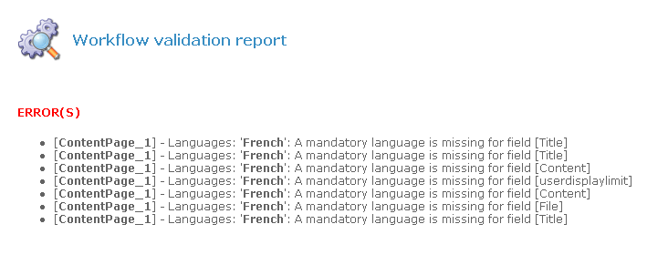

Figure 5-25: Check of the mandatory languages during the publication process

1.7 Managing Pages

Now that we know how to update the content of a page, let's try to modify the structure of the web site. In this section, we will learn how to create a new page, to link pages together or to move a page in the site.

Global Site Understanding
Basically Jahia is a tree. The home page of your site is the trunk, the pages are the branches and the fields are the leaves. You can add a new branch directly to the trunk - the first level of pages - or to another branch - the nth level of pages.
Once your tree is created, you can use cross-links between branches to go directly from a point of your tree to the other (internal links).
Keeping this comparison in mind while creating your site will ease your understanding of the system.

Adding a new Page
Your first action is usually to add a new page in your site.
To create a new page, you have to be located one level above the page you want to create, and then click on “Add a page”.

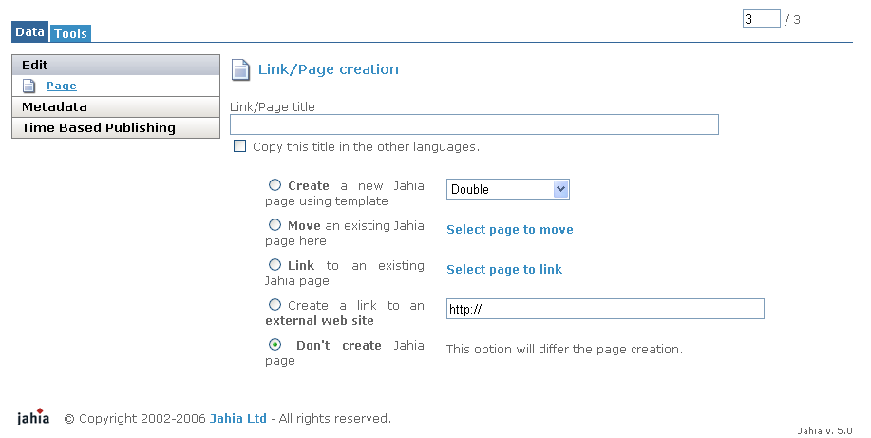
Figure 5-26: Create a new page

Five options might be available to you (your template developer may have specifically limited the number of fields you can select):

1. Title: Type in the title you want to give to the new page. The title will appear as a navigation link in the current page. Thanks to the languages flags, you may immediately input the title of your page in different languages.

2. New JAHIA Page Using Template: Is a pull down menu giving you a number of prepackaged templates to choose from. A template is a predefined layout (with colors, borders, shapes, i.e: "look & feel") in which you will be able to add new content.

You may not see all the available templates in the site. Templates also have permission rights. Check with your Site Administrator if you can not access a specific template.

3. Select page to move: Displays the list of all the pages you can move under the current page. You need write permission on a page in order to move it elsewhere in the site. Just select the page or the section you want to move by selecting the corresponding radio button and click OK.

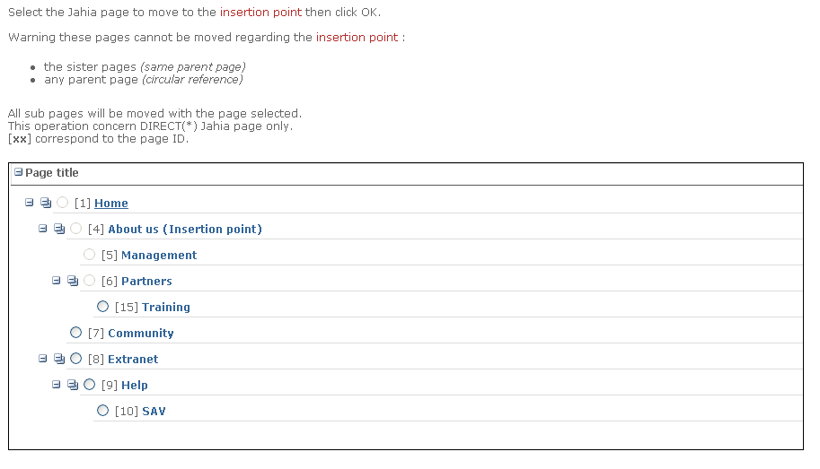

Figure 5-27: Select a page to move

Simply select the page you want with the radio button associate to the page name and click on OK

4. Select page to link: Creates an internal link to one of the existing page in the site. Only page where you have some read permissions are available. Just select the page you want to move to link to by selecting the corresponding radio button and click OK. This selection can be done either in tree view, where you see the pages as a sitemap, or in flat view, where pages can be sorted by page ID, by name or by level. The same applies to the “move page” feature.

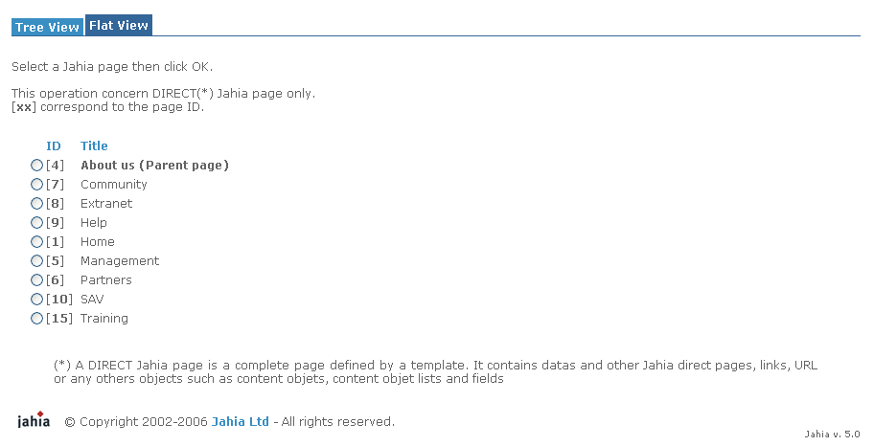

Figure 5-28: Select a page to move in the Flat view

5. Remote URL: The chosen URL links you to any other site you wish to go to. Type in any URL you wish to link from your portal.

Make sure the URL begins with: http:// You can also link to files or directories on a local server if you are working on an Intranet and all people have also access to the same network disks. In that case the link will be similar to:\\server\documents\

Now, click on OK. On the page you should now see a link with the title you gave to the new page. To start editing it, you only have to click on the link and go to the new page.

Staging Mode
Once you have finished creating your new page, it will only appear in staging mode and not in the live published web site. Similar to other field based modifications, you will have to go through the Workflow interface to validate your newly created page.

This option is quite useful as you can build complete sub web-sites and validate several pages together at once so you only have complete and finished sections going live.

Moving a page
The system to move a page is very similar to the one to create a page.

To move a page or a set of pages, you have to be located one level above the future destination point. Then, just make as if you wanted to add a new page, but at the place of choosing the option [New Page], choose the option [Move Page]

Crosslinking towards an existing page
The system to link towards an existing page is very similar to the one to create a page.

To create a crosslink in your menu, you have to be located one level above the future destination point. Then, just make as if you wanted to add a new page, but at the place of choosing the option [New Page], choose the option [Link Page]

Modifying the page settings
The Page Properties option allows you to administer the global settings of your page such as:
changing the page title
changing the template currently used for the page. AN Author may be able to switch to another template at any time. All the common data between the old and the new template are kept and do not need to be typed again. Furthermore, if you decide to come back to the original template later on, all the original data is not lost and will be restored again. This may be practical if you want to switch from a one column template to a two column template, for instance.

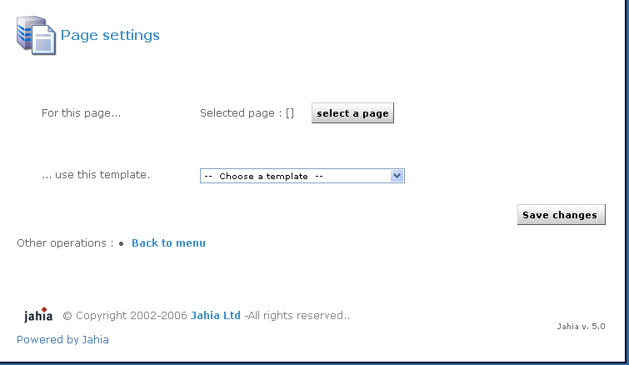

Figure 5-29: Page settings

Deleting a Page
Of course you can also delete a page and its content

Restoring a deleted page
If you suppress a page unintentionally and if it was previously versioned (the page was already approved and is now in the archives), you can use the versioning capabilities to restore your deleted page.

However, if your page was never validated before (still in draft mode) and if you suppress it, you will have no way to recover your lost data.

Deleting a page will also delete all the sub web-pages. So take care when you delete a page and verify that you are not deleting more information that what you want.
1.8 Managing Time Based publishing

With this option, you can define the time you want a page or an object on a page be published or be removed from the publication.

You have now 3 possibilities to schedule your publication, without recurrence (the default settings), daily or x days in the week.
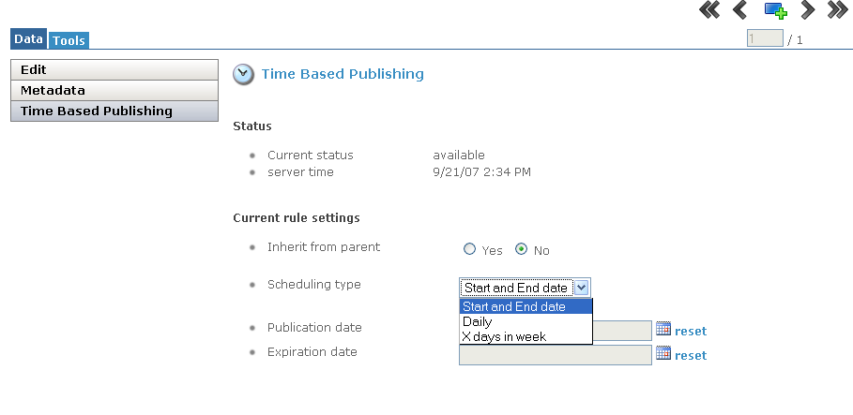

Figure 5-30: Time Based publishing – Start and End date

For the Stard and End date options, you just need to select the Publication Date or/and the Expiration Date.
For the daily options, you will need to define the start and end time.
For the x days in week recurrence, you will need to define days and time for the content to be available.

For the 2 last options which have recurrence principles, you can also define if you allow to start immediately or only at the next full publish period.

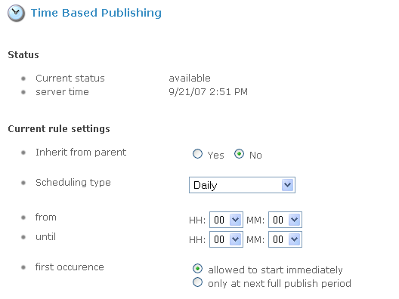
Figure 5-31: Time Based publishing - Daily

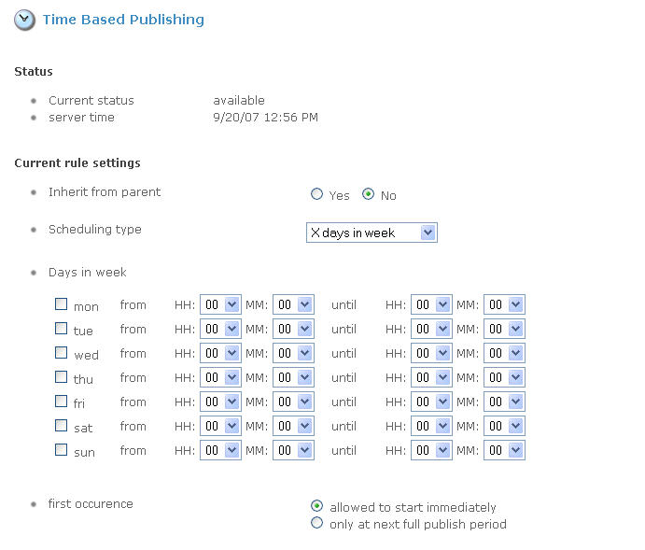

Figure 5-32: Time Based publishing – X days in week

1.9 Managing Content pick

When you create a page or an object on a page you can use the Content pick tools to re-use some content.

With this feature you can not only duplicate content but also keep an active link with the original source. So if a change occurs on the source, it will be dynamically applied on all the destinations.

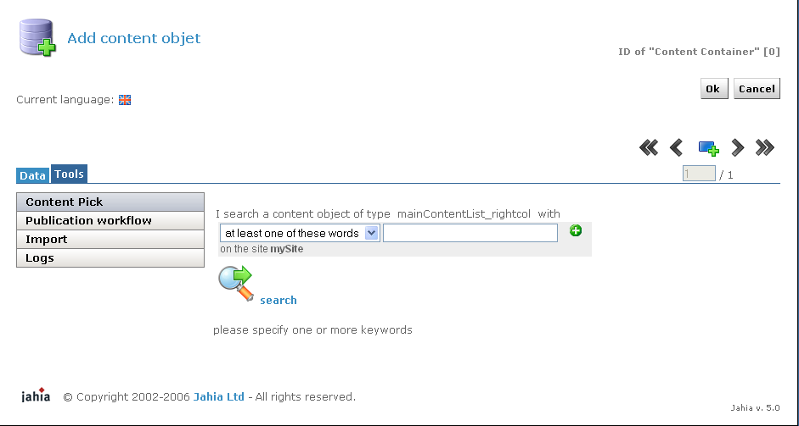

Figure 5-31: Content pick step 1

The first step is to search for a content which is compliant with your current list of objects.
For example if I try to do a content pick on a container, the search will only present me results with container object type.

Let’s search for the word “Jahia”:
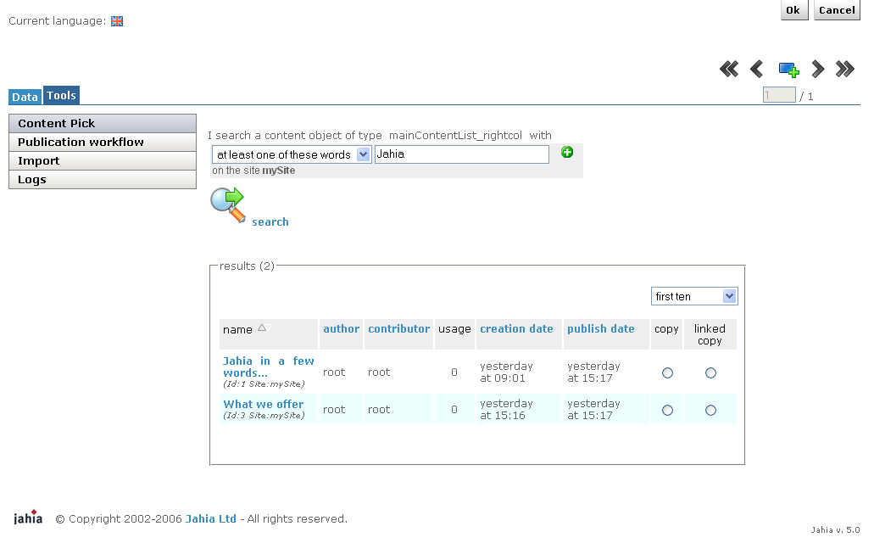
Figure 5-32: Content pick step 2

The search engine returns all containers with the word “Jahia” in one of his fields.
You have the possibility to click on the link to display the results and validate which is the one you are looking for.
When you find it, you just need to make a linked copy of it by selecting the radio button and click on the OK button.

When performing some complex operations, the back-end Jahia job scheduler is activated. You can now see that your task is currently being executed.

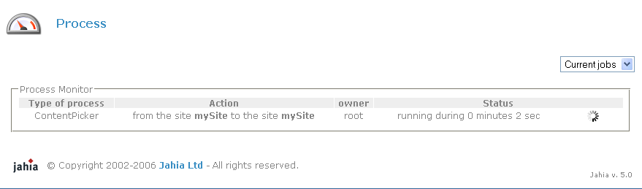

Figure 5-33: Process

When the copy process ends a reload message warns you that you can now refresh the web page to see the changes.

Preview and Compare mode
The main difference between the Live and the Preview or Compared mode is that you will be able to preview the content under modification or waiting for an approval as it will appear once validated on the live published web site.
The Preview Mode provides an exact view of the page as it will be once validated. The compared mode provides visual content highlighting to help you review the modifications between the live and the preview modes.
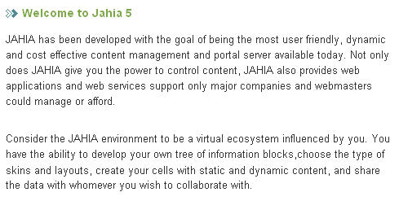

Figure 5-34: Preview Mode

To ease visualization of content modifications on a page, a Compared mode was developed. The Compared mode may be accessed in the top bar Menu.

This mode allows you to rapidly see the differences between the page in Live and in Edit mode

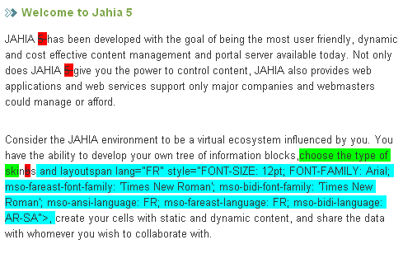.
Figure 5-35: Compare Mode

The default settings for the Compared mode are the following:
New content appears in Blue
Updated content appears in Green
Deleted content appears in Red.

Warning: your templates or certain elements of the page may not have been customized to support content comparison. These elements will then not be highlighted in Compared mode even if their content has been modified. Check with you Template Developer if it is the case.

Workflow

3.1 Status of a Jahia Page

You can immediately check the status of the current page thanks to the Page Color Status Button (next to the flag of the language in the topbar) :

Figure 5-36: Page status

Green: The page in Preview or Compared mode is the same as the one in Published Mode. No modifications have been done from the last validation.
Orange: The page is under validation. Modifications have been done and the page is now waiting for an approval. Only a Manager may now validate (or refuse) the modifications and publish content. The page is locked until validated.
Red: The page is currently under modification. This is a work in progress and every Author may still modify content.

The Page Color Status Buttons are displayed for each language as your Manager may validate a page in one language while asking for certain modifications in another language. Check the Languages section in the next chapters to know more about it.

The current selected language is displayed with a colored flag.

3.2 Workflow main options

From the Status bar, you can access the Page Validation Workflow interface. You may only access the Workflow interface if you have Write or Admin permission on the current page or at least to certain elements on the current page.
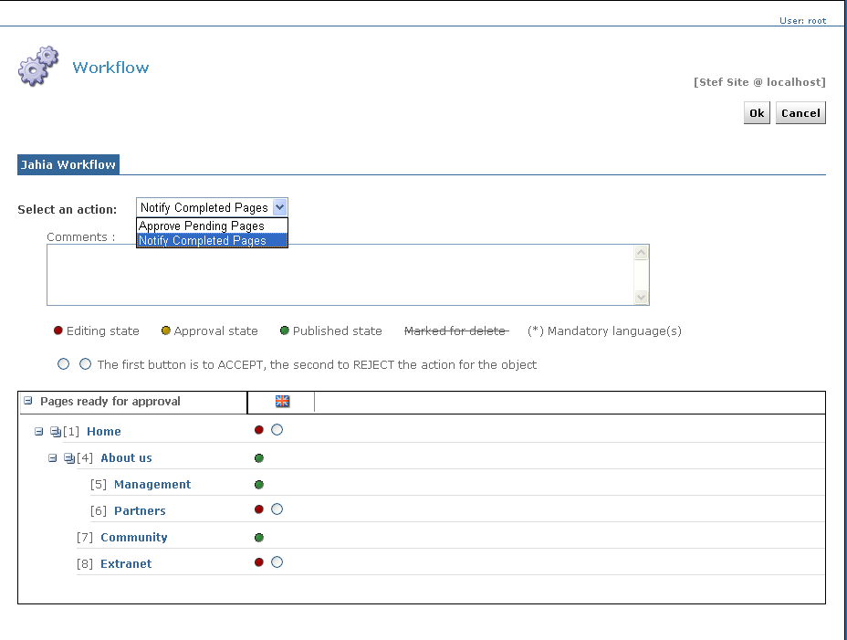
Figure 5-37: Workflow Interface

When opened, the Workflow interface displays only 2 levels of pages. You can of course expand and collapse each section to display more levels by clicking on the “+” and “-” signs.
The icon allows you to expand all level of a section with one click. If you wish to expand completely the tree of the website, you can proceed to the following:
- Click on the “-” sign of the Home page to collapse all pages. Only the Home page will then be displayed.
- Click on the “expand all” icon (). You will then have the full tree of your website expanded.
Please note that the all-expanded tree can take some moments to load depending on the size of your website.

Basically the workflow lets you:
Request a page approval (Notify a page) if you are an Author
Validate a page if you are a Manager

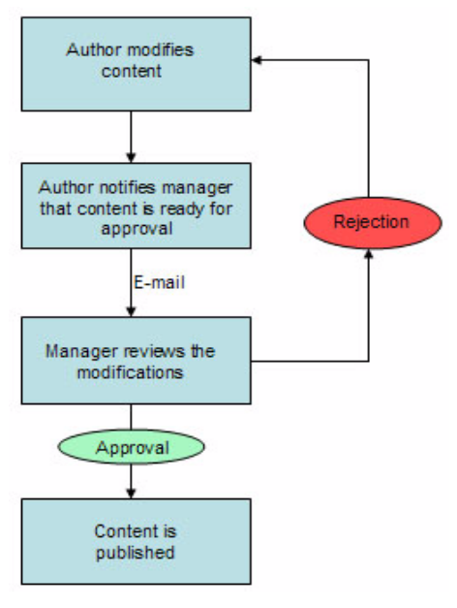

Figure 5-38: Workflow process

The usual edition process in Jahia is the following:
- One or several Authors edit and if required translate the content. This can be done on a single page or on complete set of sub web pages (e.g. your new Marketing section).
- Once the Authors are satisfied with the modifications, one of them initiates a request for approval.
- He selects the page to notify (several pages may be selected at once).
- All the pages waiting for an approval are now blocked in edition until a final validation occurs.
- The Managers review the content modifications.
- The Managers can then accept or refuse the pages. Approval may be done on a page per page and language per language basis.
- If accepted, a new archive version of the prior live content is automatically created in the database and the new content goes live.
- If refused, the page goes back to the editing mode. Authors may edit content again to correct errors.

Rule 1: Author
To summarize, an Author may: Add new content or add new sub pages
Modify/Suppress/Move/Rename existing content objects
Translate the content
Send a Request for Approval

Rule 2: Manager
A Manager may:
Do the same actions as an Author if he cumulates Write and Admin privileges.
Set the permission rights (default: rights inheritance apply = permissions from the previous page)
Validate or Refuse the Requests for Approval

All the workflow process can be apply at a container level.
In that case you will see directly the container in the list of “Pages” ready for approval.
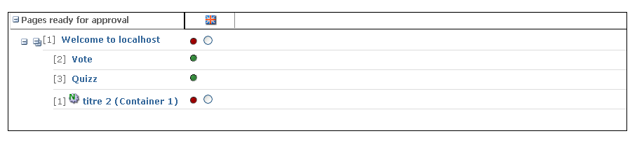
Figure 5-39: Workflow on a container

3.3 Other Workflow Options

Multiple validations at once
The Workflow interface automatically displays all the sub web pages on which you have adequate permission rights (Write or Admin). You can then select several pages at once (to avoid going on each web page individually) and initiate a request for approval or a validation.

If you wish to validate or notify all pages in one language, you can select all pages by clicking on this small icon below each flag:

This will select all pages in editing/approval state in the given language. You can of course then unselect certain pages. If you click again on the same icon, you will reverse the state of each select box: checked boxes will be unchecked, and unchecked boxes will become checked.

You can validate a sub web page even if the parent page is still under modification. The page will then not be directly available through the Jahia menus. You may however access it through a direct url if you know the exact page ID. This is especially useful if you want to validate pages while reviewing them even if the parent page is still not ready. This will avoid you to come back later on the page to validate it.

Per language validation
Jahia proposes to notify or to validate a page on a per language basis. Indeed it is sometimes useful to be able to publish only a sub set of pages in a specific language and to wait on translations to publish other languages later on

Mandatory Languages Validation Process
Partial language validation is not possible for mandatory languages. Each language sets as mandatory by the Site Administrator shall be fully translated before a notification or a validation is possible.

To ease content management in multiple languages, the workflow interface indicates to the Authors the fields that have not been properly translated

Workflow notifications
Each page flow (a request for approval, a page refusal,…) may be commented. All the comments are sent by e-mail to the various page Authors and Manager if their e-mail address has been configured correctly in their user settings (cf. Administration Guide). These notifications might be useful for an Author to warn his manager of the completion of a section or for a Manager to summarize to the Authors why the page was not validated.

Workflow Error detection
As mentioned above, the workflow will indicate for each page the various errors. Errors may be of two categories:
Translation missing
Other validation errors

Manager role
This chapter describes all the action a manager can make.

Managing users rights
One of the strength of JAHIA is its ability to delegate the administration and the edition of the website (or part of it) to other users. The Jahia User management, described in the “Setting Rights” section, is based on a standard, well known approach with users and groups. Jahia may also be linked to an existing LDAP server for single sign-on purpose.
Settings rights is a feature giving you a high level of security in limiting the information available to your users. For example, confidential information can be published only for users who have the rights to know about it. Moreover, groups of employees may benefit greatly of this feature by working collaboratively and effectively on their active projects without letting other employees see their work in progress.
This feature is only available to Content Managers and not to the Authors.
1.1 Rights Architecture

What is an ACL (Access Control List)?
All the underlying security system of Jahia relies on the concept of ACL. By understanding this concept, you will be able to more easily manage your web site security settings.
Access rights exist at several levels:
pages
containers lists
containers
fields
The objective is to ensure that people cannot access information that is confidential or irrelevant in their daily work. Permissions can be allocated to Users (individuals) or to Groups.
You may think of these access rights as a separate file that is attached to every object of content of Jahia (a page, a container or a field). This is called an ACL (an Access Control List). An ACL lists the permission rights available for certain users and groups. So when you modify the permission rights, you modify in fact this list.
There is three important rules you have to retain:
Automatic Rights inheritance
When users or groups have specific permissions on a content object (usually a page), they keep automatically the same rights on all sub-pages created starting from this point (do not forget that a Jahia web site is a tree). The same is valid for all the sub-containers lists, sub- containers or sub-fields. By default all the sub-content objects inherit from the permissions granted to the parent object. To follow on the comparison with the tree, you may imagine that only certain objects of content have a specific ACL file, all the others will look into their parent object to check if such a file exists. If their parent object does not have such a file either, they will look into their grand-parent object file and so on until they know who can access or modify their content.
If the security permissions are not correct at a certain level in your tree, you may then decide to override certain rights (creating a new ACL file by granting or denying certain permissions on a sub-page, a sub-container list, a sub-container or a sub-field). If you do not modify any security settings, inheritance will always prevail.
This rule prevents you to spend too much time managing and customizing the site security as, in most cases, inheritance will be the most adequate setting.
Always keep in mind the entire tree of permissions.
Given the inheritance mechanism, you never edit the permission of a given content object alone but you modify the permissions for all the sub objects of content as well. This ACL will then also be used on all the sub-elements (sub pages; sub fields).
Once you have assimilated this principle, you will understand why you can not simply delete a user from a page but you will have to override his current permissions.
For example if a user has some write permission on the home page, you may want to create a new ACL entry for this user in a sub page of the site (e.g. to restrict some of his permissions). Then you copy the current user permissions and modify them. But if you now try to delete this ACL entry, the inheritance mechanism will prevail and the previous settings of the user, inherited from the home page, will come back again.
You will have then to keep the ACL entry for this user but to remove him some of his previous permissions (e.g. deny all permissions).
A user always has the highest level of permissions in case of ACL overcrossing
For example, if a user is explicitly denied a certain access right (e.g. can not write on this page) but at the same time belongs to a group which has this particular permission, the user will still benefit from the access right in question.

1.2 Settings Rights
Let's try now to put some permission rights on a content object (here on a page).
On the page you want to set rights on, click on Page Settings, the following window will pop- up. In the main folder, you will have the following four options: Edit, Metadata, Rights, and Time Based Publishing. Select the Rights link:
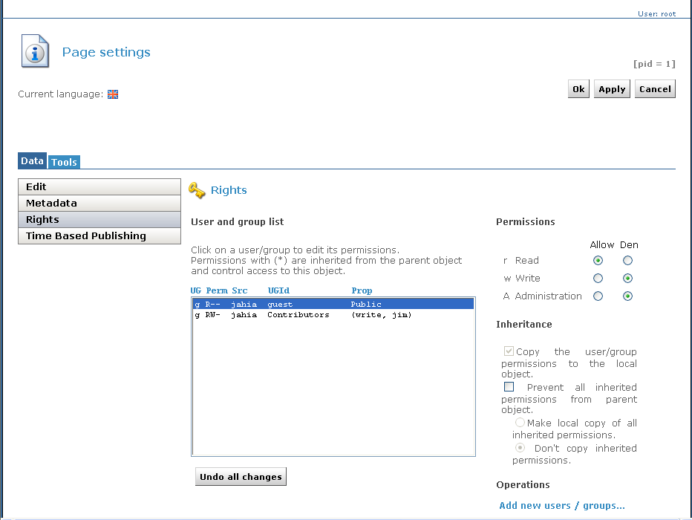

Figure 6-1: View rights window

In this pop-up interface, you can see a list of users or groups with different arguments. All these elements may be listed in ascending or descending order by using the “up/down arrow” icon.
- Group or User indicator: indicates if the ACL entry is a user or a group
- Permission rights indicator: indicates who will have the rights to:
(R)ead (view the page only)
(W)rite (add or remove elements, create new pages, change the page template)
(A)dministrate (define user rights, see logs; approve workflow)
- Inheritance indicator (“*”): indicates if the ACL entry is inherited from a parent object or not.
- Name: Name of the Group or of the User
- List of Users: Partial list of users in the case of a Group

Thanks to this screen, a Manager may immediately know who can access this page and with which level of privileges.

Add a new User/Group
The Content Manager can now try to add some new users or new groups.
By clicking the Add New Users/Groups link, the following pop-up screen will appear.

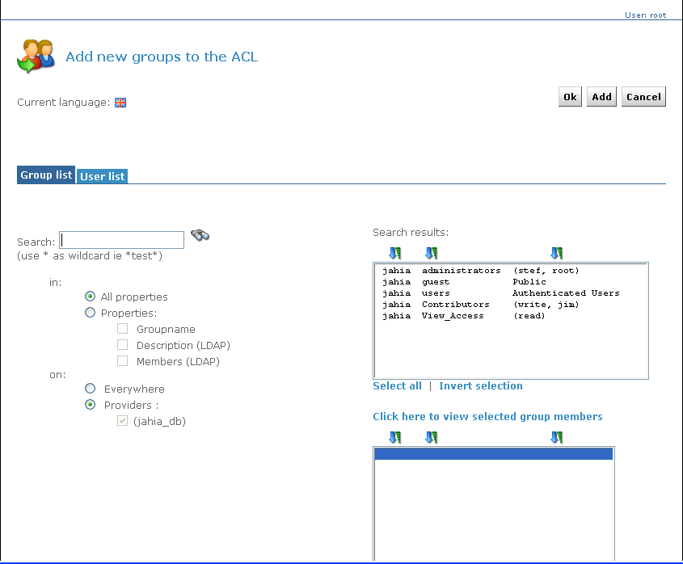

Figure 6-2: Select News Users

You can now select the users or groups you want to give some privileges to on the current page. For example, click on a new unlisted group or user, and then click on OK. The new Group (user) has been added to the ACL. To promote the use of Groups in your site (more easy to manage on a long term basis), the Group interface comes first.

By default a newly added Group/User will only get a read-only permission. You will have to edit his permissions in the upper right panel if you want to grant to him more rights.

Remove a User/Group
Let's try now to remove a user or a group. First, look for all the users and groups ACLs that are not automatically inherited from a parent object (all those that do not have the "*").
Now that you have found a local user or group, select the one you want to remove. Click on the Remove select box. Automatically the words - REMOVE - will replace the name of the selected user. Nothing will be done in the system until you click definitively on the OK or APPLY button. We strongly suggest you to use the APPLY button to manage permissions to be sure of your final security settings before leaving the interface especially with the inheritance mechanism. So let’s click now on Apply.

Two scenarios are now possible:
1) The user disappeared of the list
The user was removed and has no more permission on this object of content.

2) The user is back again with a (*)
The user was already declared in a parent content object. So when you deleted him locally, the inheritance mechanism prevailed. The user is then still listed but with a (*) and with the permissions of the parent object. To "delete" such user, just copy locally the user and modify all his permissions to "Deny". The result will be the same as if it was deleted. The new permission settings will override the inherited once.

The Inheritance Options
You can find in the lower right side of the interface two options to manage inheritance:
1) Copy the user group permission to the local object
This operation lets you make a local copy of all the inherited user permissions. You may use this command if you want to modify several user privileges on your current content object at once.

2) Prevent all inherited permissions from parent objects
This operation stops all inheritage starting from this object of content. Let's imagine you have some dedicated pages in your sitemap with information only available to the Direction. Your company recruits a new secretary and the Manager decides to grant to her some publishing rights on the home page to edit the company news. Automatically, because of the inheritance mechanism, the secretary will gain publishing rights on the whole web site. To avoid such a backside effect, this option let you create a barrier to the inheritance mechanism from a certain point. We however strongly recommend you to use groups instead of users to manage permissions and to only introduce new users inside existing groups. This will help limit such inheritance problems.

1.3 Setting rights on a field

Click on the update button of the field and proceed to the same operations as with pages.

1.4 Setting rights on a container list

Click on the update button beside the Container List and proceed to the same operations as with pages.
You cannot set rights on fields into a container if the template does not provide an update button on each field.

Permission rights on a given field inside a containerlist
As a containerlist is a group of several containers, you may want to let only some users modify certain fields and let others modify the others. To do it, just click on the "Update" icon of the ContainerList, and then in the Field Right folder. You can now select the various fields and decide which user can read, edit or administer which field in your containerlist.
For example, in an address book, you may want that only some authors may see or edit the salary field or the grade of the employee. However any author may change the internal phone number field.

Example:
Open the container list properties window by clicking on the corresponding icon :
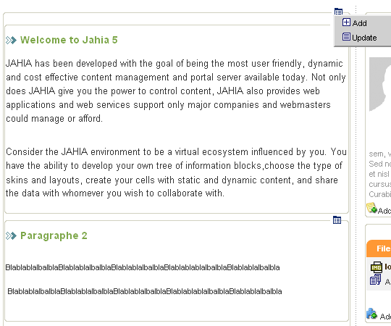
Figure 6-3: List properties

- Then choose the Field rights tab.

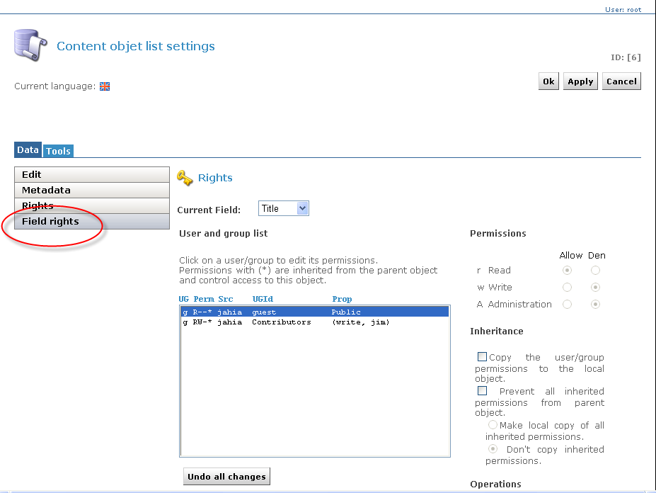
1
2
3

Figure 6-4: Fied right panel

Choose the field you would like to change the rights (1)
Choose the group or user you want to remove the ability to edit a given field listed in the fields list (2)
Remove all permissions (r,w,A) if you want to completely hide a field in the Add or Update Container popup for a given user or group. (3)
Remove Write and Admin permissions (w,A) if you want a field to be read-only, not editable in the Add or Update Container popup for a given user or group. (3)

Examples of different layout of a same Update Container popup but with different permissions settings on fields ACL:

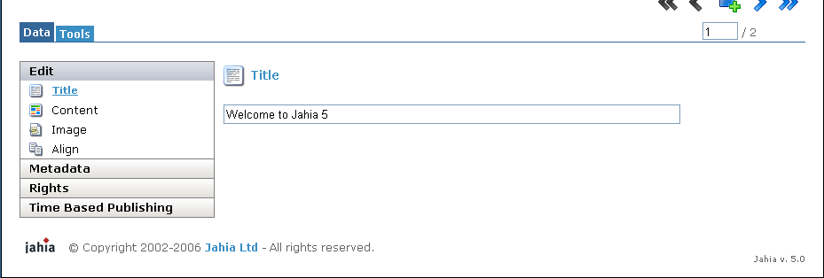

Figure 6-5: All fields are editable

This is the default layout with default field ACL settings. All the fields are editable.

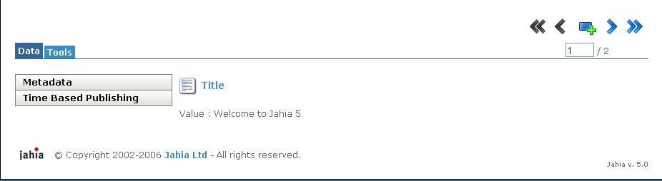

Figure 6-6: Title field is no more editable but in a read only mode

The same Update Container popup but for the current logged user, Write and Admin permissions (w,A) have been removed on the fields “Content”, “image” and “Image align”. The user can see all the fields, but he will only be able to modify the field Title. If Read permission would have been removed on these fields, only the field “Title” would have appeared.

Managing publication workflow
2.1 Workflow Definition

By default, Jahia will use the Jahia standard workflow for the pages of your site.

In this section, you can define a new workflow for your entire site by defining it on the homepage or you can define a new workflow for a specific page.
You can also define a workflow at the container level.

The administrator can reach the publication workflow by clicking on the Page properties.

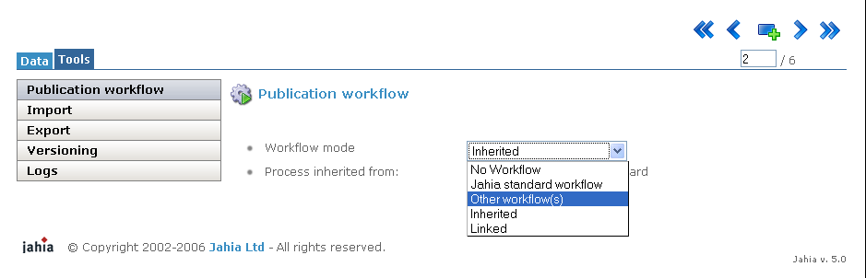

Figure 6-7: Workflow selection

He may choose between different workflow modes:

No workflow: the content will be immediately published after the author validation

Jahia standard workflow: the content will be published after the notification then the validation of a “Manager”

Other workflow(s): the administrator of the page will delegate to external system the publication management workflow of Jahia (N-step validation workflow module)

Inherited: default option > the page inherits of the type of workflow defined on the parent page

Linked: the page doesn’t have a dedicated workflow > the validation of the parent page will validate automatically the linked page

2.2 N-Step Workflow

The N-Step Workflow Module allows managers to select different workflow on the pages they are in charge of.

These workflows may have several steps depending of the manager selection or the inherited workflow fixed on the parent page.

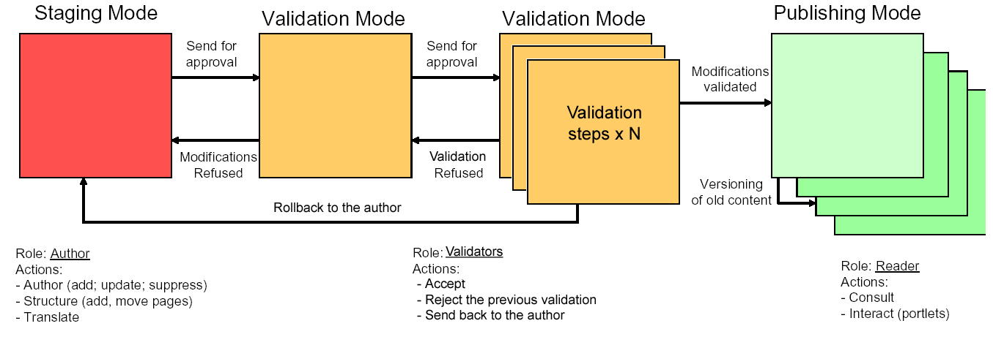

Figure 6-8: N-step Workflow

One or several authors enter or modify content. Once the modifications or translations are done (e.g. the creation of a new Marketing section), they send a request for approval to a Manager.

Several validators are then in charge of reviewing the changes, refusing or accepting the previous validation or rolling back the content to the author. The last validator will be in charge of finally publishing the content.

Once approved, the new content is then available to the Readers. A version of the previous content is automatically stored in the system as an archive (versioning).

You can immediately check the status of the current page thanks to the Page Color Status Button.


“Validators” replace “Managers” in the N-Step Workflow Module: in the Jahia standard workflow, “Managers” are in charge of content validation.

These managers need to have administration rights on the page.

By using the N-Step Workflow module, validation of the content can be delegate to people named “Validators” with only the right to preview the content (with write access to the page).

People with administration right on pages will have the ability to select the type of workflow they want to associate to the pages.

They are also in charge of defining the mapping between each steps of the workflow and the users. They may decide to be in charge of one or several steps in the validation flow to.

To choose the N-step workflow module, the page administrator will select “Other workflow(s)” mode and “N-step workflow”.

Then he will choose a workflow in the drop down menu named “Process” and define the mapping for each role / step with the users.

In our example, the administrator selected the workflow named “Three validation steps”:

Step 1: Notification of the content (must be the author of the page)
Step 2: Initial validation
Step 3: Final validation

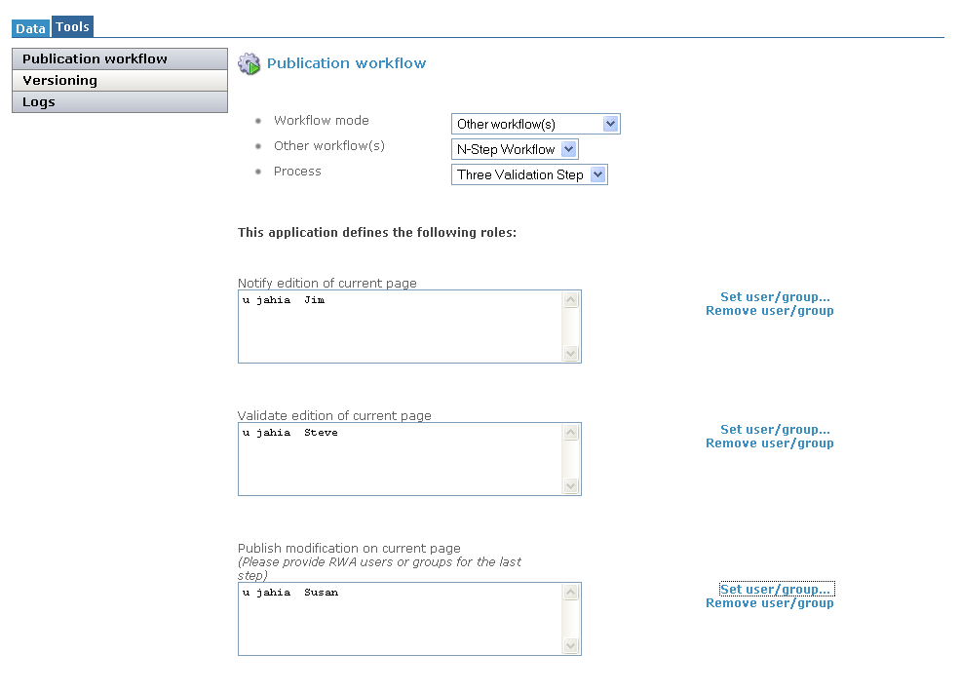

Figure 6-9: workflow three validation steps

By clicking on “Set user/groups” for each step of the workflow, you need to define who will be responsible for.
In our example, we named Jime for the step 1 as he is the author of the page, Steve for the step 2 and Susan for the step 3.

All the people involved in the validation process must, at least, have read and write rights on the page in order to preview the page and access to the workflow interface.

As the author and in charge of the first step of the workflow (step 1), Jim clicks on the “workflow” button in edit mode, selects the page he wants to send in the validation process, put a comment (if needed) and clicks on “OK”:

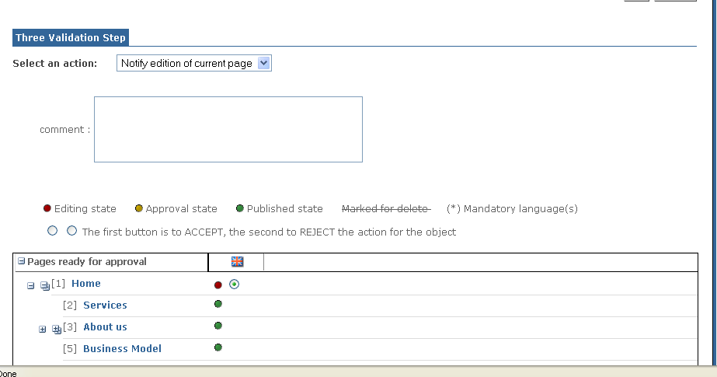

Figure 6-10: workflow three validation steps - notification

Steve receives a notification mail: he needs to validate the new version of the page. He goes to the page (content locked), logs in Jahia, following the link he saw on the mail:

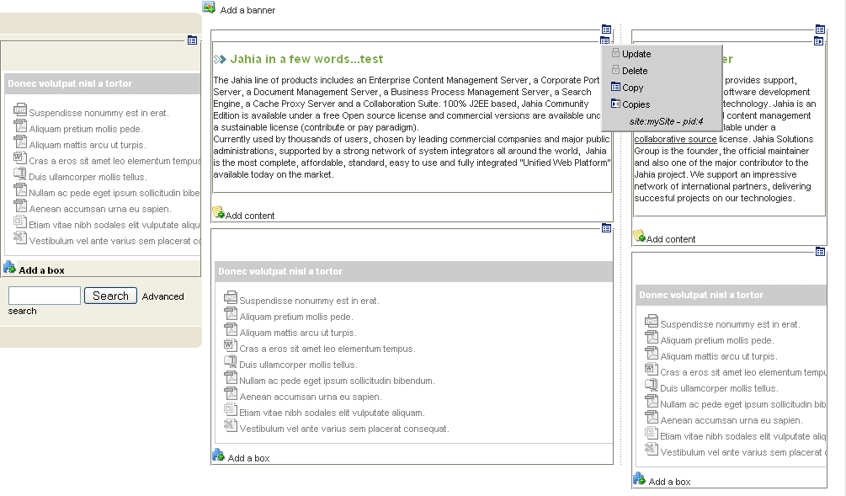

Figure 6-11: workflow three validation steps – content lock

and clicks on “Workflow” to validate or reject (back to the author) the content:

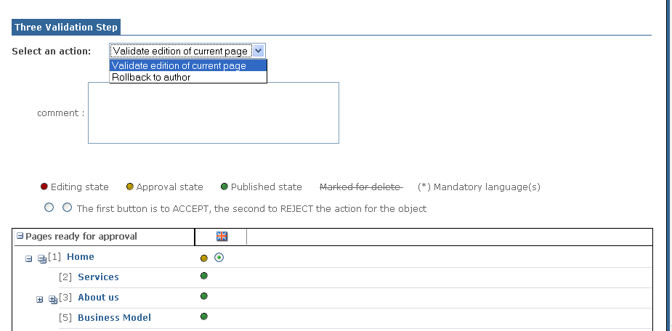

Figure 6-12: workflow three validation steps – validation

If Steve validates the content, a notification mail will be sent to:
The author (Jim)
The final validator (Susan)

Susan will have three options:
Rollback the content to the Author (Jim)
Rollback the content to the first validator (previous step / Steve)
Validate the page (Final Validation)
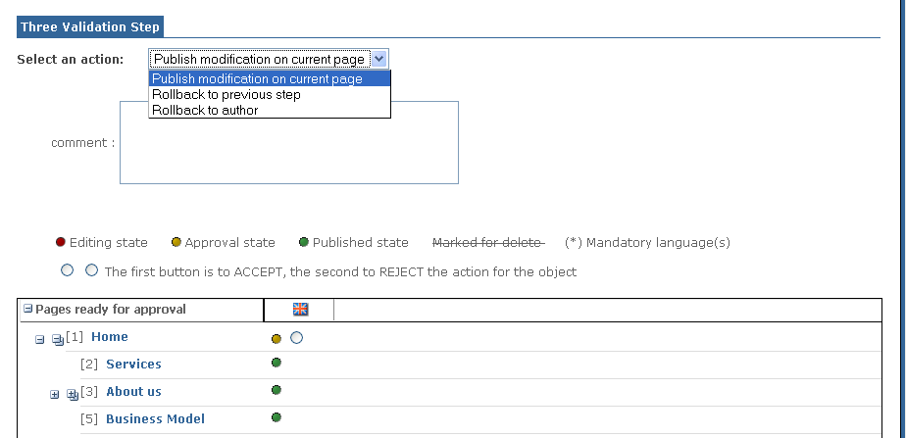

Figure 6-13: workflow three validation steps – publication

If Susan rejects the content to the previous step, a notification mail will be sent to the previous validator and the author.

If Susan rejects the content to the author, a notification mail will be sent to the author.

If Susan validates the content, a notification mail will be sent to all the people involved in the validation process from the author to validators.

Managing archived Versions
All the content objects are automatically archived when you validate content.
2 versioning interfaces are available to the Manager and lets him restore an archive of any content object:
one which give him the possibility to restore the all site or a sub-site, accessible with the page properties menu
one available on the page or container only, accessible with the container’s action item
3.1 Restoring several pages

Select the task to perform

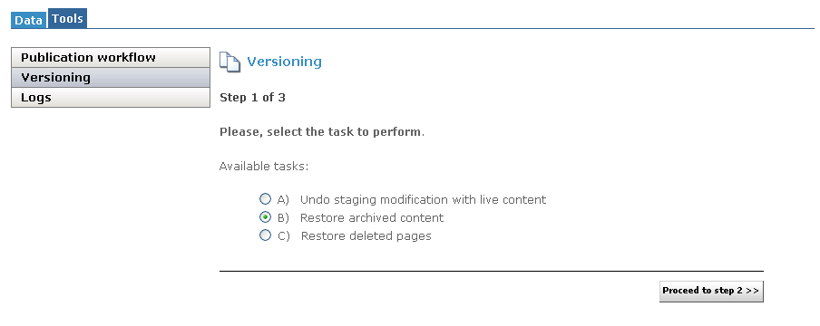

Figure 6-14: Versioning mode

When you access the versioning interface (page properties) three main options are available to you:
- Undo Staging modification with live content
This option deletes the current content in draft mode and replaces it with the live content. Useful if you did a mistake and want to start your modifications back again starting from the existing content in live mode.

- Restore archived content
This is the more complex option. This process let you restore a page, a section or a complete web site at any date. Jahia will also restore the correct structure of your site at the chosen date. For example if pages have moved several times or were deleted, the archiving service will restore them correctly at the right place in the Jahia structure.

- Restore deleted pages
This option is only available in the page properties interface or on a page field. It allows you to “undelete” pages that you suppressed by errors.

Select the pages to restore

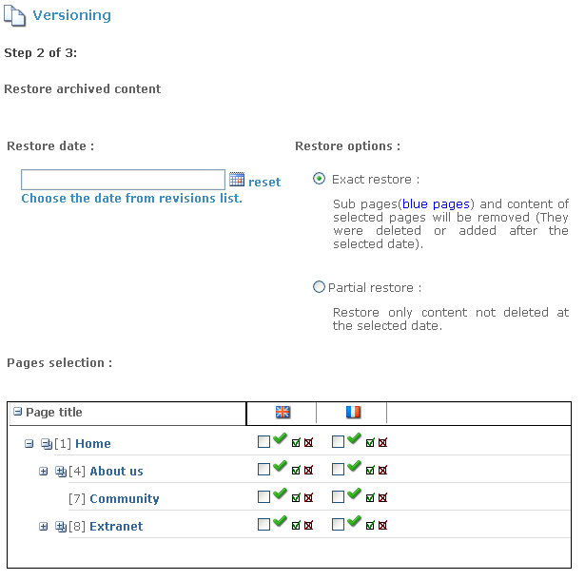

Figure 6-15: Versioning Step 2

Several options exist and are explained below:
Exact Restore:
- Sub pages (blue pages) and content of selected pages will be removed (They were deleted or added after the selected date).
The exact restore will restore exactly the web page as it was at the chosen date. All the pages or content added afterwards will be deleted.

Partial Restore:
- Partial restore: Restore only content not deleted at the selected date.
The partial restore will only restore the content that existed at the selected date. All the other elements added afterwards will stay untouched. This option is practical if you want for example to restore some news that were deleted one month ago but you want to keep all the news added since.

Once you have chosen the restore method, you will have to choose a date.
Two options are here also possible:

1) Manual input
2) Choose a date from the list of archives

The manual date input lets you chose any date you want. This option should be chose if you want to restore the site at a specific date (e.g. 31.07.2006) without using the revision list.

The second option let you choose a date from a list of all the archived versions. From this list you may see various options letting you choose the restore period and the scope of archives.

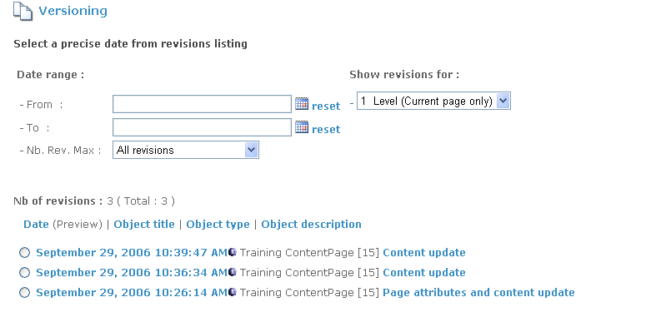

Figure 6-16: Select the version to restore in the archive list

Each archive can be restored and consulted immediately. Just click on the date of the version and you will get a preview of the page at the selected date. This will let you find the exact archive you want to restore.

[Advanced Users] By clicking on the description, you will see a list of all the fields that have been modified during the validation. You can then see field by field what the content was at the selected date.

Once you have selected a date from the archive list, you may come back to the previous screen. The selected date now appears in the interface. However, the sitemap list is not adjusted to the sitemap of the portal at the selected date.

Pages Selection:
You can now select the page(s) you want to restore. You can restore a single web page, a section (a group of pages) of a full web site.

Once done, you can move to the latest step of the wizard.

Confirmation

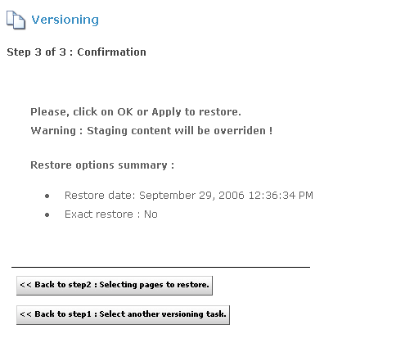

Figure 6-17: Step 3 Confirmation

This step will ask you to confirm all the options you selected during the process. Do not forget that your content in draft mode will be suppressed and overridden by the archive without any way to restore it as it is not archived yet.

If you are ok with your settings, just click on the Apply or the OK button.

3.2 Restoring one container

When you access the versioning interface (with the action item on the container) a list of all archived containers will be displayed.

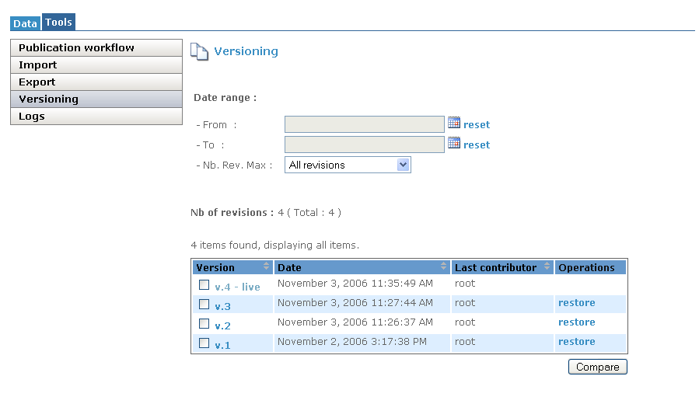

Figure 6-18: Versioning on a container

You can click ok the link to view the comparaison between the live environment and the archive version.
You can also select 2 particular versions and ask for a comparaison with the “Compare” button.

When you have selected the right one, you just need to click on the restore link to access to the confirmation page and click on OK to process the restore.
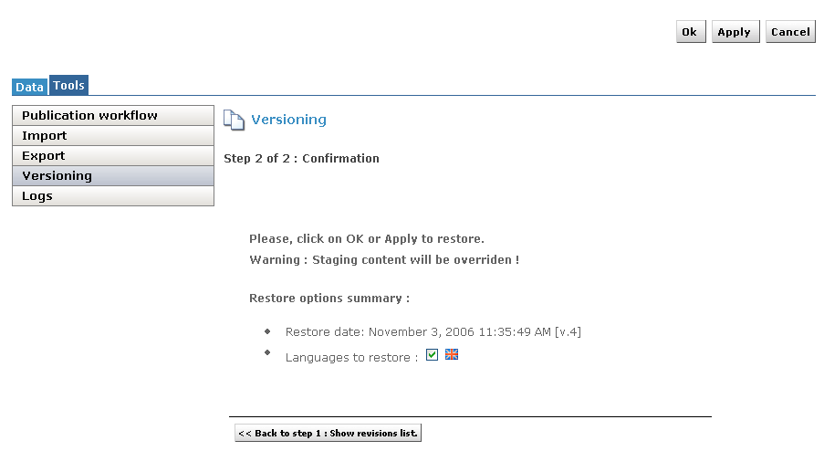

Figure 6-19: Versioning on a container confirmation

Import / Export
Import

With this new version of Jahia, you can now import or export the content of your site.
To import some content you need to create an import file.
In this zip file you will need:
An export.xml file by language which will contain the structure and content of the site
A filesacl.xml with all the permissions
A categories.xml with all the categories
A users.xml with all the
And all the files or images you want to import.
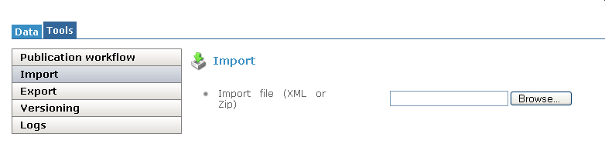
Figure 6-20: Import screen

Export

For the Export, you have 3 differents type: Complete live content, Complete staging content, Differential, and 3 differents export format: XML Content (current language only), zip with XML content and zip with XML content and files.

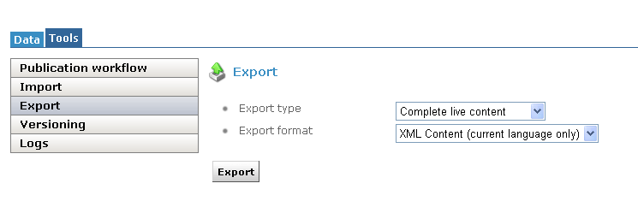

Figure 6-21: Export screen

Managing Logs
Jahia logs all the actions performed by the users. Each Content Manager may access to the logs of every content object where he has the right permissions (Admin rights).
The logs automatically consolidate all the actions performed on all the sub content object. So for example the home page logs will consolidate the logs of the whole Jahia site.
Jahia logs only archive the actions performed by the authors and the content managers. This may not be considered as a site usage log that trace all the clicks performed by the various users. For such logs please use the standard Apache logs or your application server logs. Check with your system administrator to know how to configure them.

Logs are by default limited to the 500 latest entries. The Site Administrator may increase the logs to an higher limit. However due to the current implementation of the logs, we do not suggest to logs more than 10’000 entries. This option will be improved in future releases.

Site Administrator Role
This chapter describes all the action an site administrator can make.

Site Settings
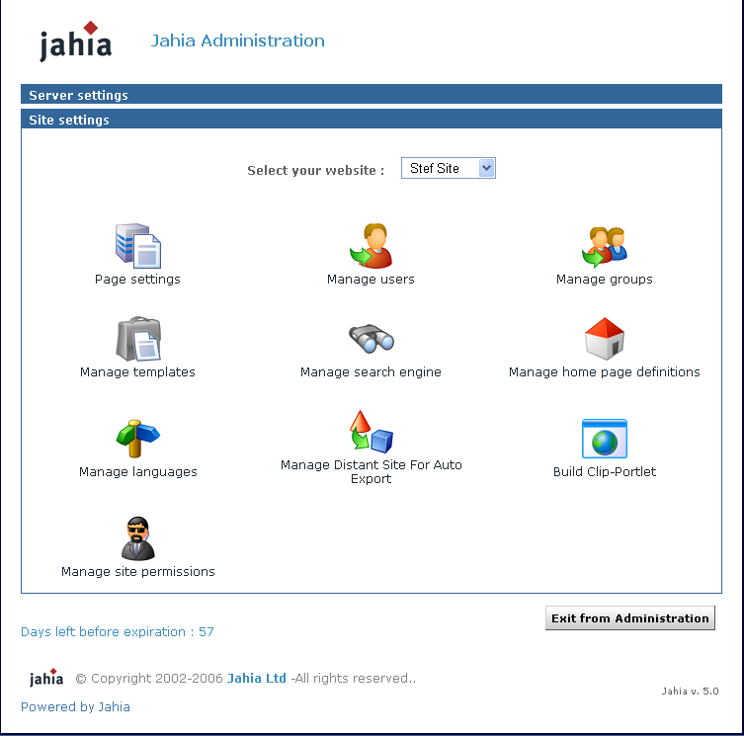

Figure 7-1: Site settings
This screen includes all administration tools to manage one custom virtual site. The Super Administrator can see this panel for each virtual site by selecting any site in the drop-down list. The site administrator (siteadmin) has no access to the Server Administration Panel, he can only access to this screen and only for the virtual site(s) he is managing.

1.1 Page Settings

Figure 7-2: Page settings

Through this menu, you can switch templates for any page of your Jahia Portal. This allows you to change the layout of a given page by applying a new template to it. Please note that both templates should share common fields to be able to output the same data. Please refer to the Templates Guide for more details on how to build templates.
Just choose the page you want to “skin” and select the template you want to apply. Click on Save Changes to validate modifications.
If you choose a new template which doesn’t use any field of the current template, your data won’t be displayed, but they won’t be lost. Switch again to the first template to recover your original page layout and corresponding data.
Such an option can be useful to revert from a template producing errors to a known good template for a specific page of your site.

1.2 Manage users

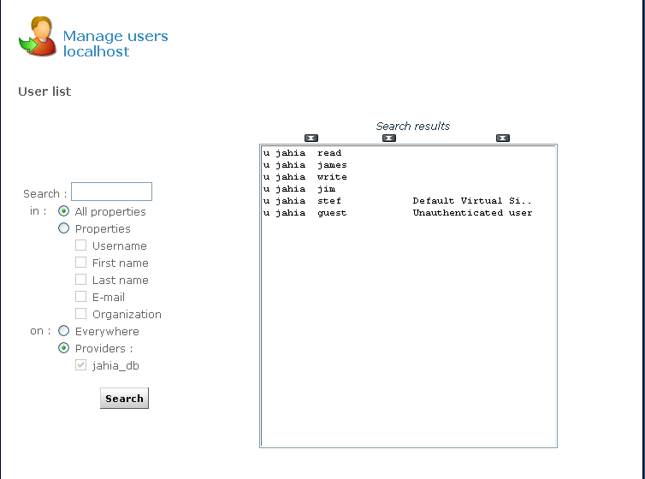

Figure 7-3: Manage Users

This interface allows site administrators to manage the Jahia users available on the current virtual site. You can add, edit or delete users, as well as insert users in groups or move users between groups. Please note that the default Jahia Administrator user as well as the guest (anonymous) user can’t be deleted. In fact the Jahia Administrator and the Root user do not appear in the list of users as they automatically have full permissions on the site.
You can also browse, search and sort users from different sources. Right now users can be either stored directly in the Jahia system or authenticated against a third party LDAP server. To learn how to configure access to a LDAP server, please refer to the “Advanced Settings” chapter.
In case you have several hundred users, you can use the search field to retrieve specific users. Wildcards can be used, for example to search all users whose name begins with “s”. Just enter “s*” in the search field and click on search. You can also sort in ascending or descending order the list of users by provider or by username just by clicking the arrows icon above the users list.
To add a user, just click on Create new user, enter required information and click on OK. To edit the settings of a user, select it and click on Edit/View selected user properties.

If you want to use the e-mail alert feature of the workflow process, you need to specify the e-mail address of the user you are creating.

Through the “Edit user properties” menu, you can also set a homepage for a user. When this user logs in and if he selects “Jump to personal home page” in the drop-down list of the login window, he will automatically be redirected to the page defined in this menu. A link to his homepage can also be found in the top bar menu once the user has logged in.

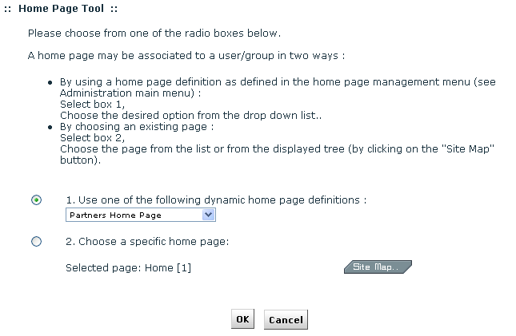

Figure 7-4: Home Page Selection

Click twice on OK to validate.
If you want to delete a user, click on “Remove selected user”. He will also be removed from all pages where he had specific rights. Please note that you cannot remove a user stored in a LDAP server.

By clicking on Manage groups, you will be able to create or delete groups and move users between groups. See next paragraph for details.

1.3 Manage groups
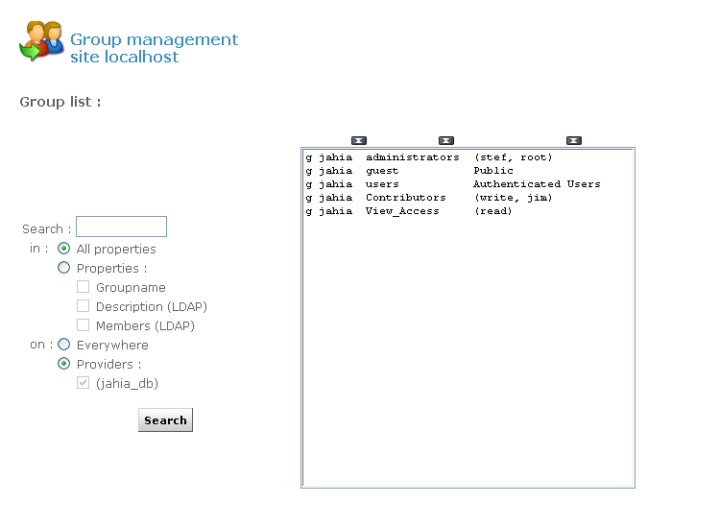

Figure 7-5: Manage groups

Three groups exist by default in Jahia and cannot be removed:
- Administrators: all users that have complete administration rights on the whole virtual site.
- Users: all users (Jahia or LDAP users) are part of this group by default.
- Guest: this group represents all the possible anonymous and logged users (Group Users + anonymous user). As the anonymous user (guest user) is considered in Jahia as a standard automatically logged user, if you only grant access to a page to the guest user, other logged users will not have access to this page. You will then need to grant access to the full guest group which includes both logged and anonymous users.

To add or remove users from one of these groups, select a group and click on edit selected group. Select one user (or press the Ctrl key to choose multiple users) and click on remove members. If you want to add new users to the group, click on add members.

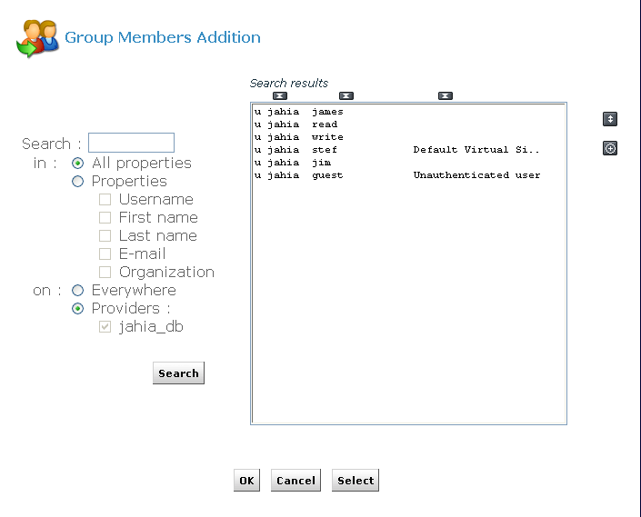

Figure 7-6: Add a new member to a group

If no users are displayed, press on search to display the full list of users. Select users and click on Ok to add them to the current group.
Two icons at the right of the panel allow you to ease selection in case you have many users:

: Select all users


: Invert selection


You can also copy groups and keep in the new group all users from the source group. For example, select group “users” and click on Copy selected group. Give the new group a name, i.e. “users_copy” and click on OK. You now have a second group containing the same members as the “users” group.

Currently, the groups of groups feature is not supported yet

1.4 Manage templates

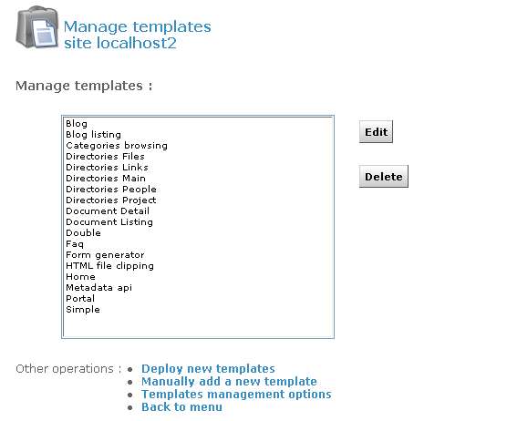

Figure 7-7: Manage template

This panel allows you to manage the different templates which can be made available to users of Jahia. As with the portlets, you can decide whether you want automatic or manual deployment. Just click on Templates Management Options to select or unselect Automatic Deployment Mode and click on Save.

If you have packaged your set of templates in an .ear file, you can copy it to the following directory:

TOMCAT_HOME/webapps/jahia/WEB-INF/var/new_templates/ name_of_your_site

If the Automatic Deployment Mode is enabled, the new templates should be available after a few seconds. Otherwise click on Deploy new templates. You will need to refresh the page to see the updated list, or to go back to the menu and then open again the Manage templates panel.

Manual templates deployment
If you haven’t packaged your templates in an .EAR file, you can still deploy them by clicking on Manually add a new template.
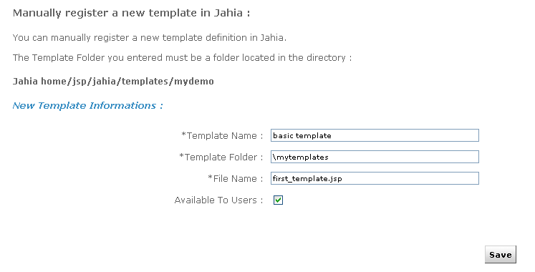

Figure 7-8: Manage template deployment

As illustrated in the above screenshot, the folder containing the templates to be deployed must be located in the following directory:
TOMCAT_HOME/webapps/jahia/jsp/jahia/templates/name_of_your_site

For example, if you are currently managing the mycompany virtual site, you will need to copy your templates in the following directory:
TOMCAT_HOME/tomcat/webapps/jahia/jsp/jahia/templates/mycompany/

First enter the name of the template as it will appear in the template drop-down menu when you add a new page to your virtual site.
Then enter the directory name in which you copied your templates, relative to the path mentioned above. (i.e: mytemplates/).
Finally enter the name of the jsp file (i.e.: first_template.jsp).

Please note that directories and templates names are case sensitive

If the checkbox Available to users is not selected, the template will not appear in the list of available templates in the drop-down menu when you add a page to your virtual site.
When editing an already deployed template, the checkbox Is the default will specify that this template should be selected by default in the template selection drop-down menu of the “add page” interface.
Click on Save. The following message will be displayed if the template was deployed correctly:

The template was installed successfully

If you have an error message, please check that the file name is correct and that it is indeed present in the directory entered.

Templates Access Permissions
Thanks to the Acess Control List (ACL) system in Jahia, you can also manage rights on templates to specify which user may have access to which templates.
Select a template and click on Edit. You can also double-click on the template name.
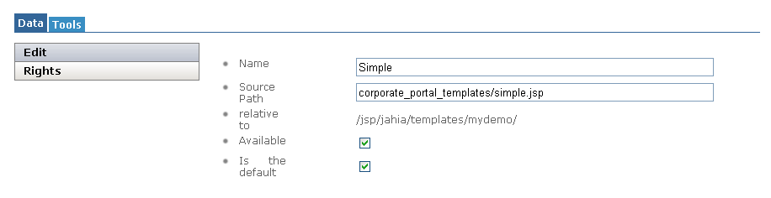
Figure 7-9: Edit template

Select the “Rights” section.
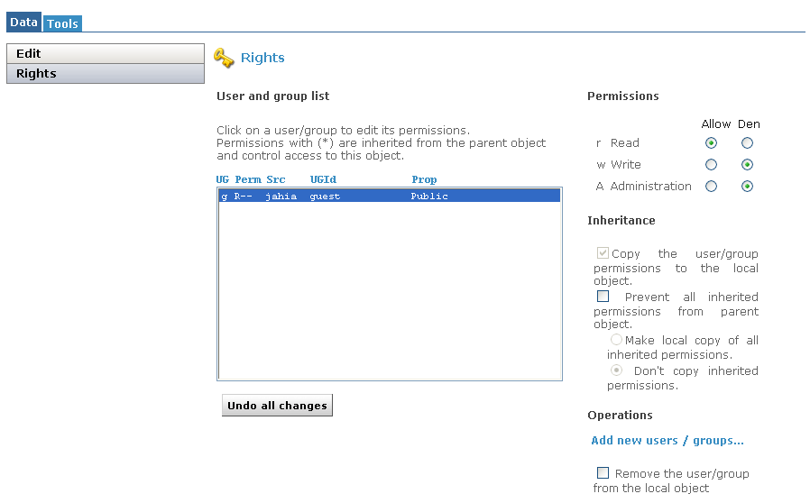
Figure 7-10: Template right management

By default every user has access to all templates, provided that he has sufficient rights to manage content and add pages on a section of the site. To remove access on the current template for a user or a group, click on “Add new users/groups...”. Choose all users/groups which should not have access to the current template and click on OK. Then select these users/groups and switch the “read” radio button from “Allow” to “Deny”. The “Write” and “Administration” radio button may be used in the future but have currently no effects.
Now the selected users/groups won’t be able to add pages based on this template, neither will they be able to switch the template of an existing page to this template.

1.5 Manage Search engine

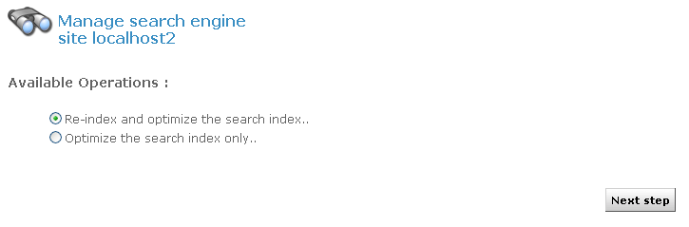
Figure 7-11: Search engine indexing

Jahia uses the Jakarta Lucene technology from the Apache Foundation (http:// jakarta.apache.org/lucene) to index content. Lucene is a high-performance, full-featured text search engine which relies on an index file, and so minimize RAM usage.
Before being able to use the search engine in your site, you need to create the index file. Normally this file is automatically created when your create a new virtual site. You will also need to re-index the site after restoring a site backup or extraction. In all the other cases, the search index will be updated in real time when content is modified or added in the system. Click on Next step and OK to index your site. Once the process is completed you should have the following screen:

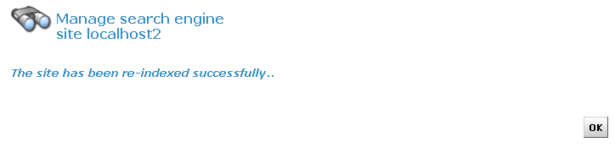
Figure 7-12: Indexing successful

As the index is stored in a file, you won’t need to re-create your index in case you need to shutdown and restart your Jahia server. You can also launch an optimization of the search index if you think it needs to be optimized.

Here is a summary of the syntax that can be used while doing a search. Detailed informtaion of the syntax can be found in the “Live Site” chapter of the End User Guide or in the query syntax page of Jakarta Lucene (http://jakarta.apache.org/lucene/docs/queryparsersyntax.html).

Boolean operations:
Boolean operators allow terms to be combined through logic operators. The search engine supports AND, "+", OR, NOT and "-" as Boolean operators (Note: Boolean operators must be ALL CAPS).

Wildcards
The search engine supports single and multiple character wildcard searches.
To perform a single character wildcard search, use the "?" symbol.
To perform a multiple character wildcard search, use the "*" symbol.

The single character wildcard search looks for terms that match those with the single character replaced. Multiple character wildcard searches looks for 0 or more characters. You can also use the wildcard searches in the middle of a term.

Grouping
The search engine supports using parentheses to group clauses to form sub queries. This can be very useful if you want to control the boolean logic for a query.

Fuzzy search
The search engine supports fuzzy searches based on the Levenshtein Distance, or Edit Distance algorithm. To do a fuzzy search use the tilde, "~", symbol at the end of a Single word Term.

Proximity search
The search engine supports finding words which are a within a specific distance away. To do a proximity search use the tilde, "~", symbol at the end of a Phrase.

Boosting a term
The search engine provides the relevance level of matching documents based on the terms found. To boost a term use the caret, "^", symbol with a boost factor (a number) at the end of the term you are searching. The higher the boost factor, the more relevant the term will be.

Detailed information and examples can be found in the End User Guide or in the query syntax page of Jakarta Lucene (http://jakarta.apache.org/lucene/docs/queryparsersyntax.html).

Although the “manage search engine” menu is available in the virtual site administration panel because there is one index per virtual site, you still need for the moment server administrator’s rights to be able to index a virtual site.

1.6 Manage Home Page Definitions

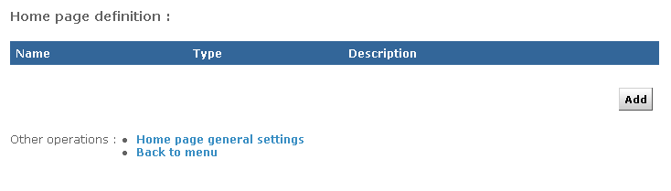
Figure 7-13: Home Page Definitions

You can set a list of Home page definition to be used as Home Pages for existing users/ groups. You can also define an Home Page which will be attributed to each new user/group at creation time.

To create a new home page definition, click on “Add”.
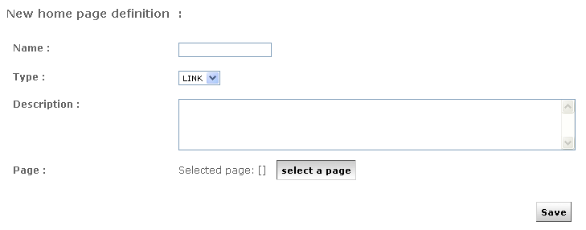
Figure 7-14: Add a new home page definition

Currently you can only create a home page definition which links to an existing Jahia page. A future release of Jahia may permit to use home page definitions to automatically create a new page based on a previously chosen template when creating a new user/group or when setting a home page for a user/group.
Once you have entered a name and chosen an existing page for your home page definition, click on Save.

To define which home page definition will be used when creating a user or a group, click on Home pages general settings. You can use a different Home Page for users and for groups.

1.7 Manage languages

From this interface you can manage all parameters related to language for the current virtual site. The upper part of the panel displays all the languages currently configured. For each language, you can select 2 options:

- Active: if checked, this language will be available in the edition pop-up and users will be able to switch to this language. At least one language must be activated.

- Mandatory: if checked, you won’t be able to validate a page until content for all mandatory languages have been completed. For instance, if you add a new page but only entered a title in English when French is a mandatory language, you won’t be able to publish it in any languages. This prevent content from being published before it is available for all mandatory languages.

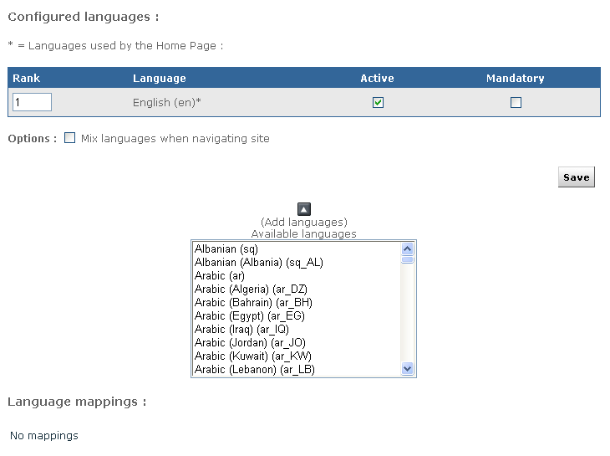
Figure 7-15: Manage language menu

For intranet or extranet purposes, you may often want to be able to display content to the user whatever the language he is currently browsing the site. For example, if you do not wish to have empty pages for languages where content is not available yet, you can activate the “mix languages when navigating site” option. This will use existing content of the other languages to fill in the blanks. You may, for instance, have some area with English content in the French part of a virtual site if this content is not yet available in the French language.

If you want to remove a language from a virtual site, just unselect the “Active” checkbox and click on “Save changes”.

To add a new language to the virtual site, select it from the list of available languages. You may notice that many languages are listed multiple times. In fact the list is based on “locale” or language for a region, so it does not only specifies a language, but also a region. Jahia will identify this “locale” settings of browsers, and can behave differently whether it identifies an French-configured browser from a Canadian user (“fr_CA”) or from a French user (fr_FR). If you wish to add the “generic” French language, just choose the “French (fr)” option.
Unless you plan to add some content specific to a country or region (like fr_CA or fr_FR), you should normally use the generic locale (fr) for a given language.
Click on the
icon to add the language to the list of configured languages.

Language mappings
The “language mappings” option is useful when you have created a site with two different locales for the same language. In for example you have both French-Canada (fr_CA) and French-France (fr_FR) locales configured on your site, you may want to specify which language will be displayed when a user with a generic French (fr) locale access your site.
Click on “edit language mappings” once you have added both fr_FR and fr_CA to choose which locale will be mapped to the fr locale.

To summarize, here is the normal behavior if you have the following configured languages and mapping:

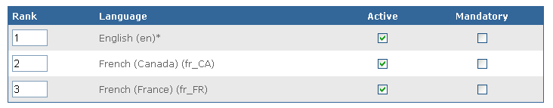
Figure 7-16: Language configured

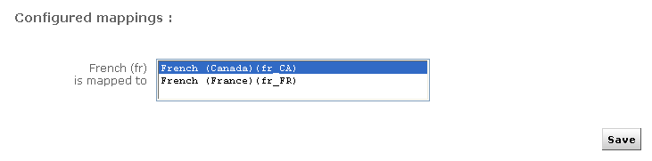
Figure 7-17: Language mapping

1.8 Manage distant site for auto export

Often site adminisrtators need to separate the intranet environment from the Internet zone. However authors ares also most of the time employees and publish content from within the intranet zone.

Thanks to this option, you can create your public web site within your private environment and replicate it on a distant Jahia server.

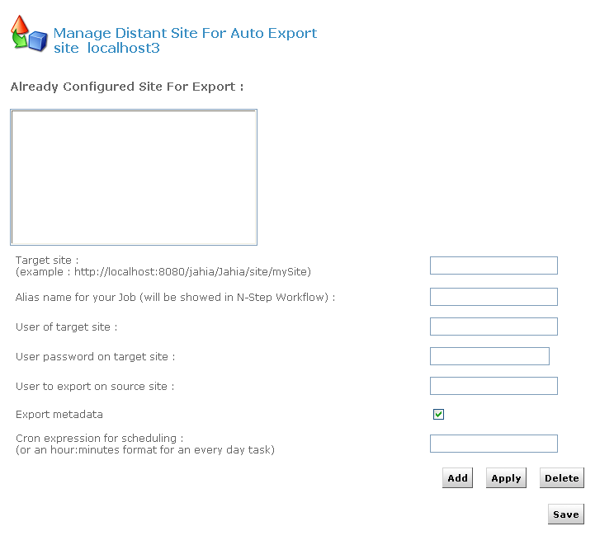
Figure 7-18: Auto Export

In order to avoid confidential and restricted information to be published on a distant public web site, only information available for the chosen user will be exported (by default the guest/anonymous user).

Jahia uses the cron syntax in order to let you select the frequency of your site replication. So you can decide to update your distant site once a week, once a day or once an hour.

Finally Jahia uses its internal XML import/export module in order to replicate the current web site.

1.9 Build clip portlet

HTML Clip Portlet

With this interface, you can easily extract train schedules, the latest stock quotes or weather information from any existing sites and generate a dynamic portlet of it.

It even manages authentification in order to access to restricted web sites.

The Webclipbuilder is wizard with 5 steps.

Configuration: set parameter (optional step)
This step allows you to define advanced parameters for the navigation module of the portlet.
Parameters definition can be find by clicking on the Help link.

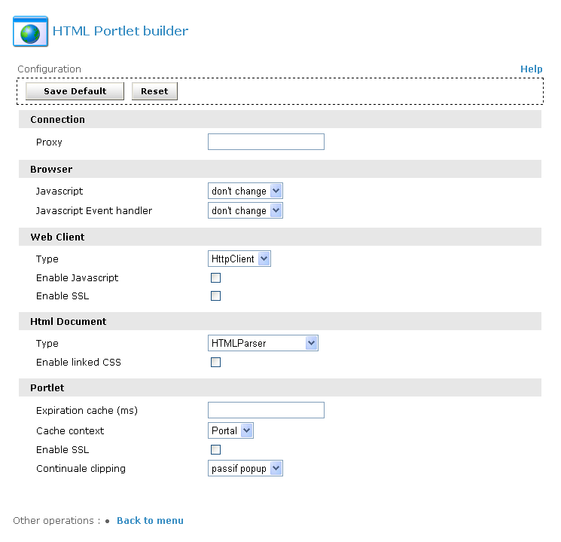
Figure 7-19: HTML Portlet Builder - Set parameter

You juste need to click on the Save Default button to save the configuration and you will have access to the ADD button.

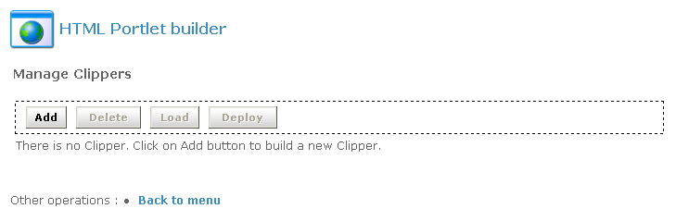
Figure 7-20: HTML Portlet Builder – Add clipper

To create a new clipper, click on the Add button.

Step 1: Clipper Description

In this step you will define the name, title, description and the target URL. In our example we will create a clipper which present you CFF timetable for Geneve Lausanne.

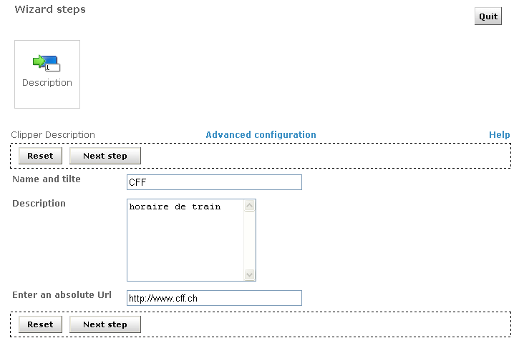

Figure 7-21: HTML Portlet builder - Description
Step 2: Clipper Recording

This part is the most important part of the clipper creation. You will be able to specify the page sequences to access to your final result.
To record a sequence, click on the Start button, and navigate normally until you access the desired page, then click on the Next step button.
Be careful; don’t click on link contained on iframe.

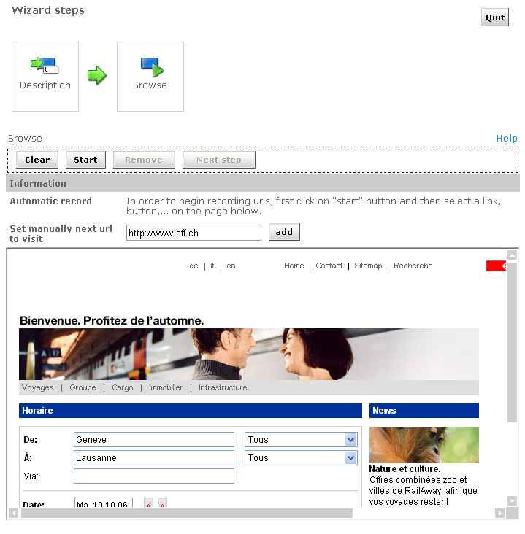

Figure 7-22: HTML Portlet builder - Browse

Step 3: Edit parameter and cut

Depending of the clipper you created, you might need parameters.
Here are the properties you can define:
Mapping: This will be the name of the parameter displayed in the clipper
Used value: Display the actual value
Use as default value: If you want to used the actual value by default
Visibility: If you want to display the parameter to the user, in our example we select the Departure and the Arrival parameters to be visible.
Automatic type Update: If you want to replace the default value by the one generated by the server. In our case we set the Journey Date to be automatically updated.

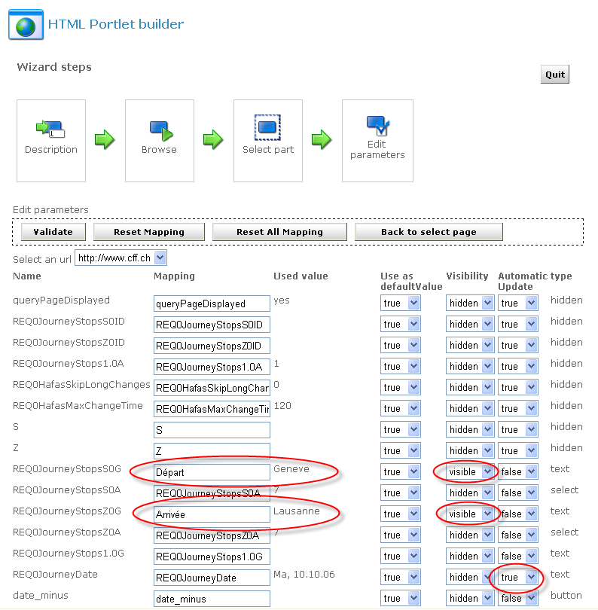

Figure 7-23: HTML Portlet builder – Edit parameter

You need now to cut your clip to select the part you want to display in the portlet.
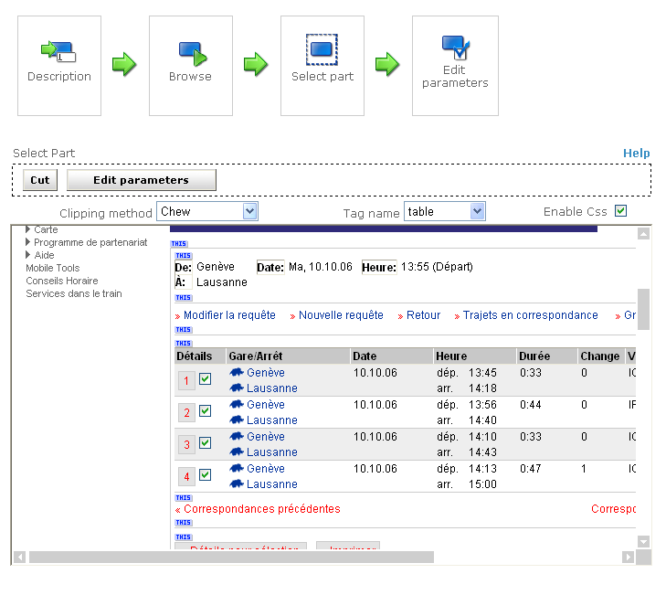

Figure 7-24: HTML Portlet builder – Select part

With the Chew clipping method, you need to select the tag which will be used to cut the selection.
You can have details about the different filter by clicking on the Help link.

Step 4: Load your clipper

To test your clipper, you just need to load it
In our example we can see the 2 parameters we define as visible and their default value.

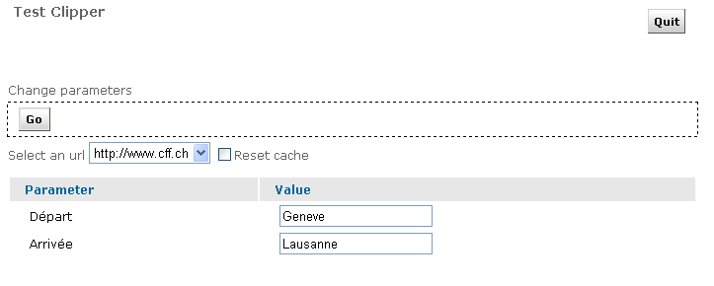

Figure 7-25: HTML Portlet builder – Load

By clicking on the GO button, you will preview the final result.

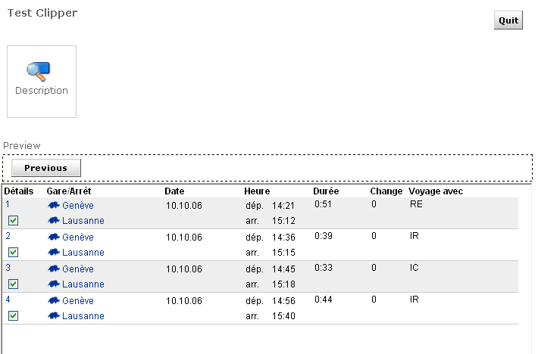

Figure 7-26: HTML Portlet builder – Preview

The last step is now to deploy it, and the portlet will be available in the list when you will add portlet.

SQL Clip Portlet

This type of portlet allows you to display any content of a database table.

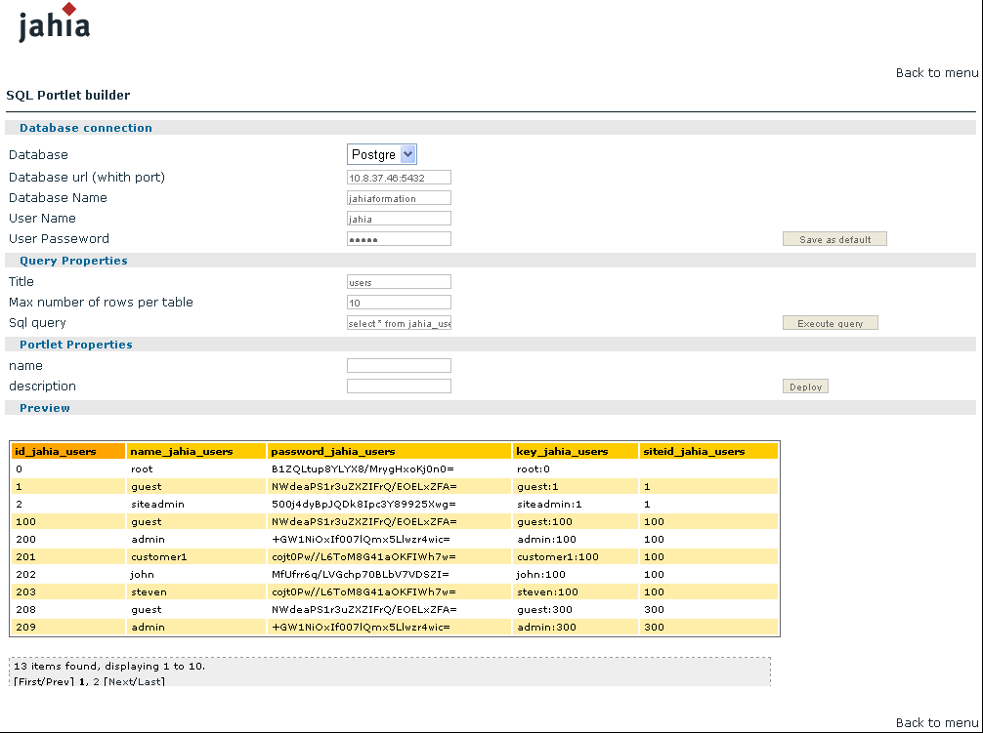

Figure 7-27: SQL Portlet builder

You need to provide the data source of your SQL DB, your SQL request and Jahia will generate a dynamic portlet with the results set.
Users will be able to sort, extract or filter the result of this SQL query.

1.8 Manage site permissions

In this area, you can delegate accesses to all the site menu features to any power users.
You can grant custom permissions for all the actions available in the edition pop-up windows or the edition menus.

As you can see in the figure, you can specify a group of user for each action available in :
The Administration panel
The Edit menu
The Tools menu
A list of actions define in the Actions tab
And the edition of the language for the author.
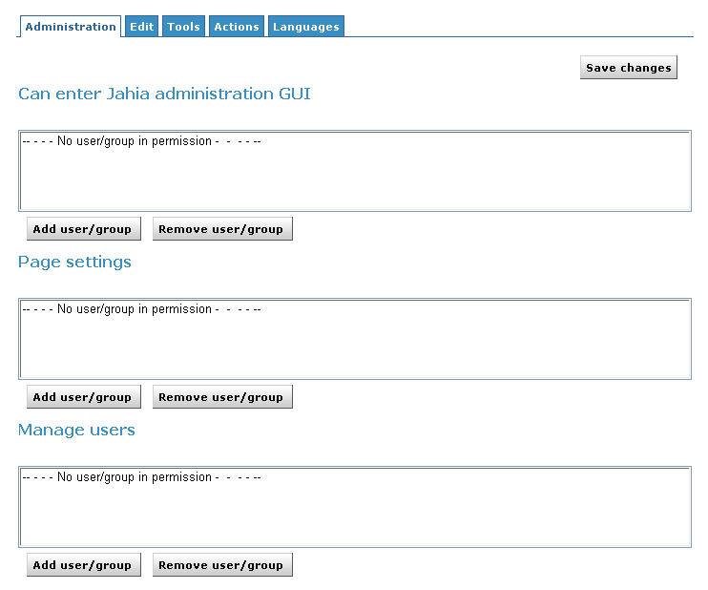

Figure 7-21: Manage site permissions

Server settings
Let’s start with the Server Administration Panel which is only available to the Root user.
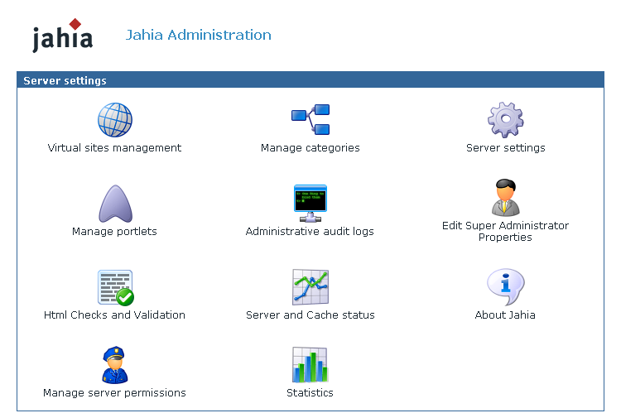

Figure 7-22: Server Administration

2.1 Virtual site management

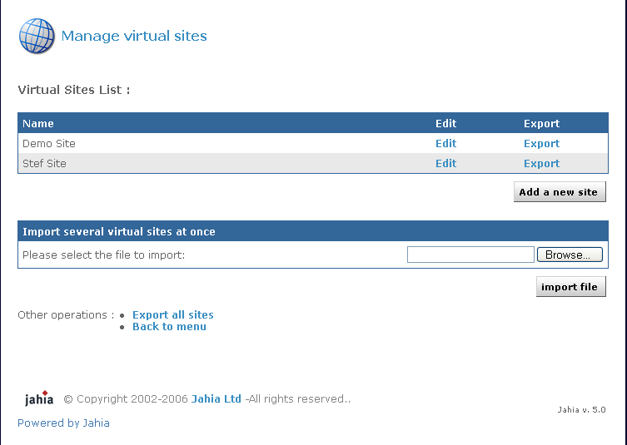

Figure 7-23: Virtual Site menu

You can create multiple virtual web sites on top of one Jahia physical server, each with its own set of templates, components, users and groups. For example, you can have one website accessible through the url www.first_domain.com and another one through www.second_domain.com, both running on the same Jahia server.

The default site created during installation appears in the virtual sites list as “My Jahia Site”. To add a new virtual site, click on Add Site. If you want to edit settings for an existing virtual site, click on the Edit button.

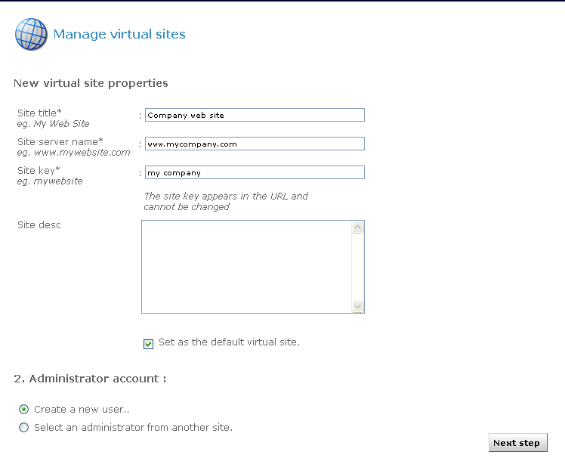
Figure 7-24: New virtual site properties

First, enter a site title. The site title will appear on the virtual site list.
Then enter a site server name; this indicates the name of the server on which Jahia runs. You can specify a URL for the site server name, for example www.mycompany.com and if your DNS is correctly configured, you will be able to access this virtual site by directly typing this url. Remember that the default port to access Jahia is 8080, so to call this specific virtual site, you will have to enter something like:

http://www.mycompany.com:8080/jahia

You also need to enter a site key. This is a keyword that will be used in the url to access this specific virtual site. For example, if you use localhost address and want to access a virtual site with the mycompany site, the url will be something like:
http://localhost:8080/jahia/Jahia/site/mycompany/

You can note that if you are using a fully qualified name to access your virtual site (i.e. www.mywebsite.com), you don’t need to use the site key in the URL.

Select then the first checkbox if you would like to make this virtual site the default site. It means that if you type the base url of jahia (i.e http://localhost:8080/jahia/ Jahia), you will be redirected to the home page of this particular site.

You then need to define the administrator account for this site. The site administrator will be able to manage users, groups, templates and components for his/her site but won’t be able to access to the Server Administration (Root only). You have the choice of creating a new user for this role or to select the administrator of another already existing virtual site.
Then click on Next step.
If you selected New User, you will need to enter requested information for the site administrator account
If you selected the second option, you will need to choose the web site from which you want to select the administrator, and then select the administrator.

Once you have created a new administrator for the virtual site (or selected one from another virtual site), you need to choose the default set of templates that will be used.

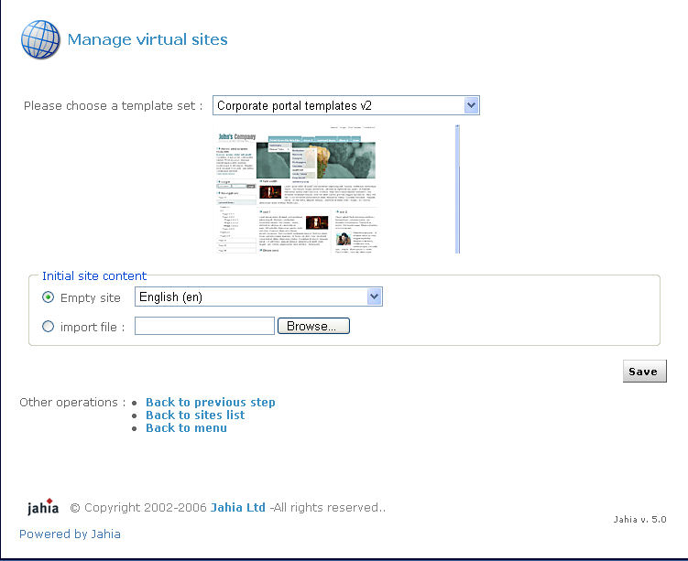

Figure 7-25: Template set selection

You can still replace afterward the templates by your own once the virtual site is created. You can see how this can be done by checking paragraph 1.7 Manage templates in this chapter.

Edit site
In this menu you can change the site title as well as the site server name. It is also through this menu that you can delete an existing site. Be aware that when deleting a site, you will also suppress all users and groups related to this site, as well as all templates, applications and file repository of the virtual site. If you want to preserve one of these objects, you can uncheck the corresponding box before you confirm the deletion of the site.

2.2 Manage categories

Content inside Jahia can be categorized for easy retrieval. It means that you can create a series of categories and sub-categories and Jahia objects can be later on associated to one or many of them. Pages, containers lists and containers can be categorized. You can then for example recover in a Jahia template all objects belonging to one category or all categories on object is associated with.
You could for instance recover on a departmental home page all the news published throughout the site which have been also associated to the category of this department. You can even re-use content from other virtual site on the same jahia server through the category mechanism, as content categorized can be retrieved throughout all virtual sites.
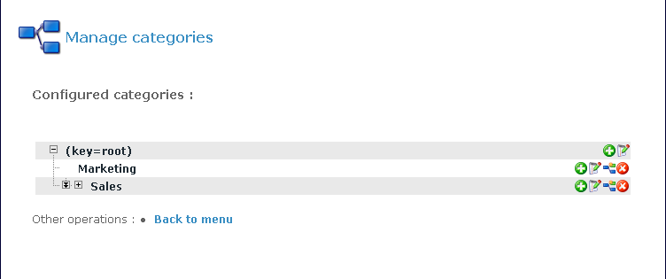

Figure 7-26: List of already created categories
For each category, you can define one or many associated properties. For instance, you can define as a property the departmental home page associated to the category, a description of the category or any other associated property. The properties can of course also be retrieved inside Jahia templates. A sample categories browsing template is provided with the default “corporate portal” templates packaged with Jahia.
To add a new category, just select the parent category and click on “” the add button.
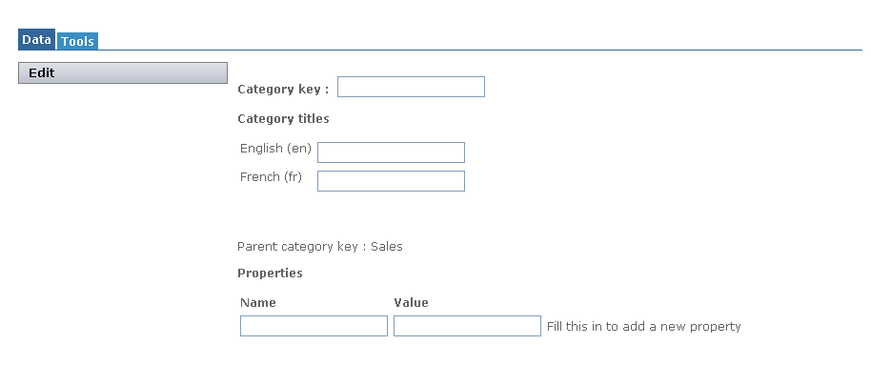

Figure 7-27: Adding a category

Enter the category key (a unique identifier for each category throughout all virtual sites), the category title for each language available on your Jahia server (if no title is entered, the category key will be used as title). If needed, enter then a property name and value and click on the Apply button. You can enter as many properties as needed.
Now when you update a page, a containers list or a container on your web site, click on the “Metadata” section and you should see the list of categories you just created under “Categories” link.

2.3 Server settings

From here you can changes the mail settings that were defined during the Jahia Configuration Wizard.

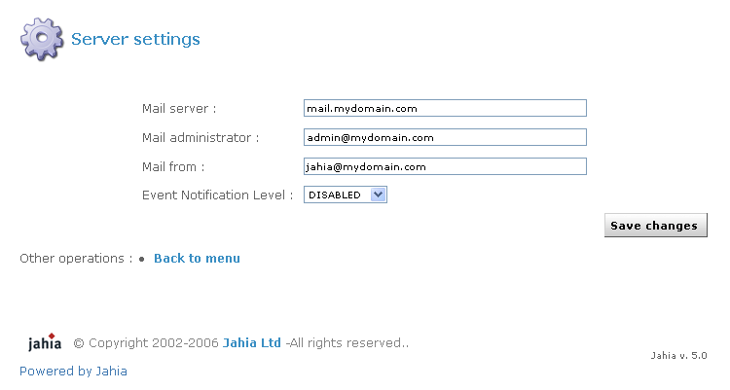

Figure 7-28: Server settings

In case you want to use the e-mail notification feature to be warned if errors occur, please enter your mail server address (SMTP server), as well as your e-mail address and the e-mail address from where the notification is sent. Then select the event notification level, from None to Paranoid. These event notifications will help you solve problems when you are testing newly designed templates. Make sure the SMTP server you are using to send notifications is configured to accept mail from the server running Jahia without needing SMTP authentication.

2.4 Manage portlets

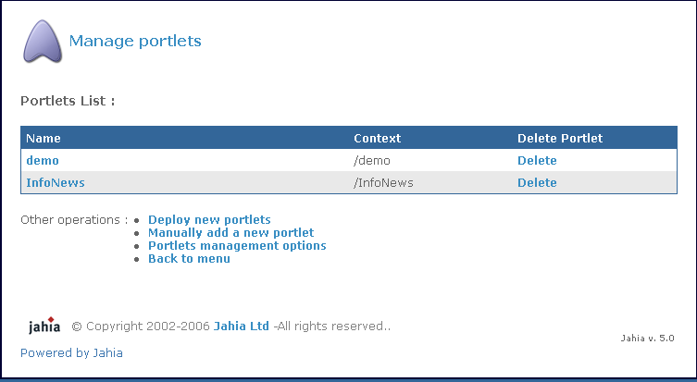

Figure 7-29: Manage portlets

Portlets (or web applications) can be easily deployed and used within Jahia. A dozen of web applications are already provided with the default Jahia installation package, ranging from a file manager to a time reporting or a forum. If your Jahia edition is not prepackaged with these applications, you may download them directly from the Jahia.org web site.

You can also develop new web applications. Please refer to the Jahia WebApps Guide to learn how to develop new applications or adapt your already existing Java applications to work within Jahia.

To deploy automatically a new component, all you need to do is copy the .EAR or .WAR file to the following directory:

TOMCAT_HOME/webapps/jahia/WEB-INF/var/new_webapps/

After a few seconds, Jahia will automatically deploy the component. Just return to the Manage portlets panel to see the new application
If you prefer not to have your portlets automatically deployed, enter the Portlets Management Options, unselect the Automatic deployment Mode box and click on Save.

To manually deploy new applications, either click on Deploy new portlets, to have Jahia search in the new_webapps directory for new portlets, or on Manually add a new portlet to specify the path to the new applications you want to deploy as well as its full name (i.e: /foo/bar/apps.ear on Unix or c:\foo\bar\apps.ear on Windows). If your application is not contained in a .ear or .war file (compressed file containing all files needed for the application), you can also specify a path to the directory where the webapps resides (i.e /TOMCAT_HOME/webapps/mywebapp/).

2.5 Administrative audit logs

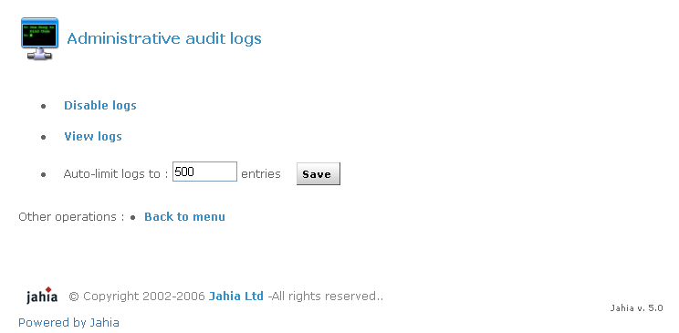

Figure 7-30: Administrative audit logs

Jahia keeps track of all manipulations made on the site (log in, log out, add, delete,...) with date, time and user who performed the action.
By default, Jahia keeps the last 500 entries. To display the audit logs, click on view logs.

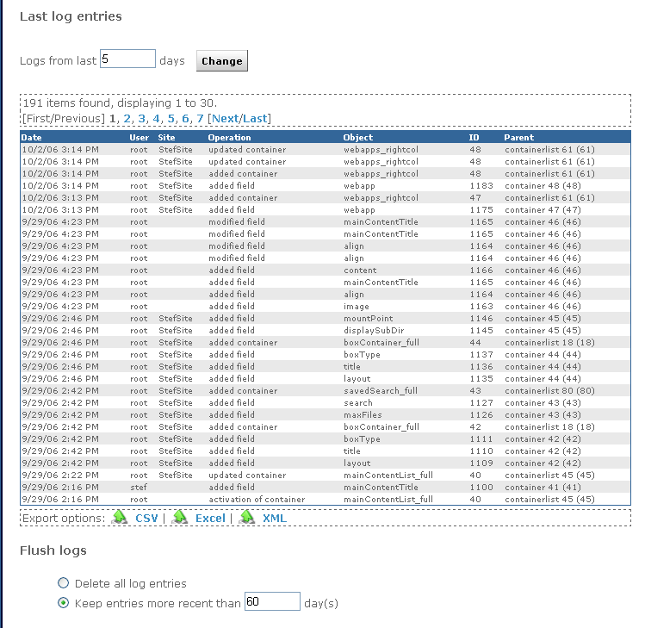

Figure 7-31: View logs

The audit log can be filtered or directly exported in various different formats.

2.6 Edit super Admin properties

You can at any time change settings (name, password, e-mail address,...) for the Jahia Super Administrator.
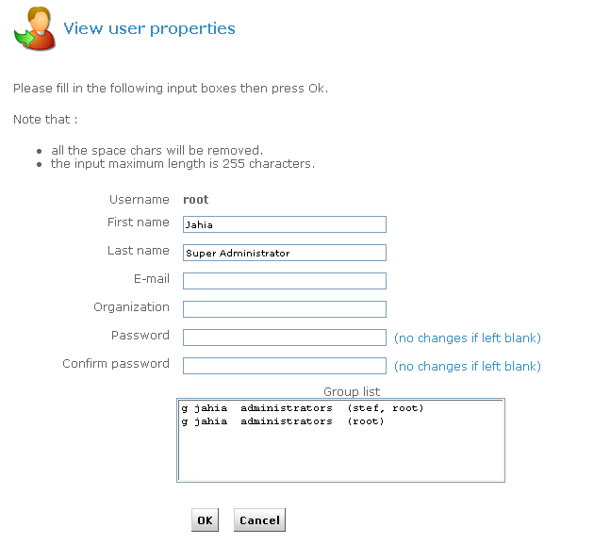

Figure 7-32: Super administrator properties

Just modify the information and click on OK.

2.7 HTML Checks and Validation

The HTML Checks and Validation menu allows you to customize internal HTML code verification (internal links cross checking, WAI, …) which Jahia can optionally perform on rich elements.

Display HTML Editor List
Through this panel, you can display the HTML editors which are configured to be used inside Jahia. Two editors are available by default: a FCK Editor which works with most internet browsers and a Simple Text.
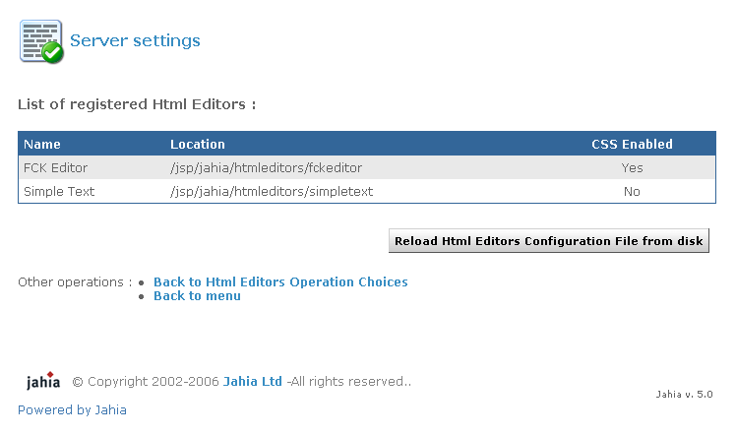
Figure 7-33: Registered HTML Editor

A configuration file exists, which defines which editor should be available as well as the display order of the editors and the default editor. This file, htmleditors_config.xml, is located in the following directory:

TOMCAT_HOME/webapps/jahia/WEB-INF/etc/htmleditors

Changes to this file can be reloaded without restarting Jahia, by clicking on the “Reload Html editors configuration file from disk” link.
To learn how to change the order in which the various HTML editors are displayed in the Jahia edition GUI and how to add other new editors, please check the “FAQ” chapter.

Markups to remove when parsing text content

In this section, you can choose which HTML tag should be automatically removed from the rich texts entered by editors.
For example, if you want to remove the <FONT> tag, you just need to Add a new markup

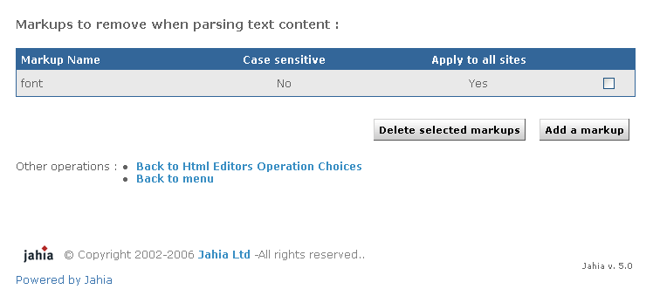

Figure 7-34: Add a markup

Manage site settings

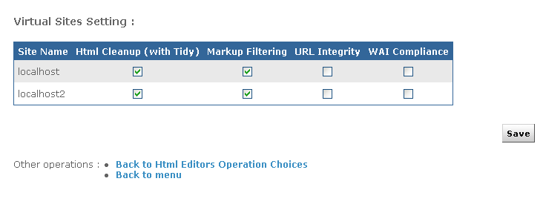
Figure 7-35: Manage sites setting

You can access here to a by site summary of all activated options performed on rich text objects.
The HTML Cleanup option will allow you to define if rich text elements will be parsed and automatically corrected in case of HTML syntaxic errors.
The Markup Filtering option allows you to automatically remove certain tags entered by the editors.
The URL integrity check will block validation of an element unti cross-references pointing to this element are not connected first in order to limit possible 403 or 404 errors in live mode.
And finally the WAI Compliance option will force WAI Level 1 compatibility while editing a rich text element.

2.8 Server and cache status

The server status informs you about the state of Jahia’s various cache systems, as well as memory used and database connection pool. This can be very helpful to help detect potential problems. You may also use this interface to flush one or several Jahia back-end caches.

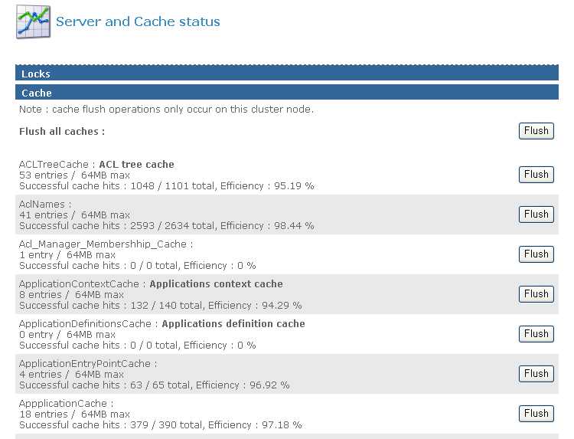

Figure 7-36: Jahia Cache status and flush

Jahia automatically caches already accessed HTML pages in memory in order to improve the response time for the next users. Access to pages already available in the HTML cache proxy can be between 10 and 20 times faster than non-cached pages as it avoids any connection to the database or any other time and CPU intensive java operations. Indeed Jahia just needs to output a pre-existing copy of the HTML page rather than dynamically assembling all the required content objects.
Of course, each time the content of a page is updated, the copy of the concerned pages in memory will be automatically flushed by the system. For example if you change the title of the home page, all the pages of your site will be automatically flushed as all the navigation menu will then become obsolete.
By default, the HTML cache (as well as other back end caches) is not limited in size. As Jahia stores one copy of the HTML page per logged user (each user may have different permissions and then a different HTML view of the same web page), this may use quite a lot of memory according to the size of your site.

2.9 About Jahia

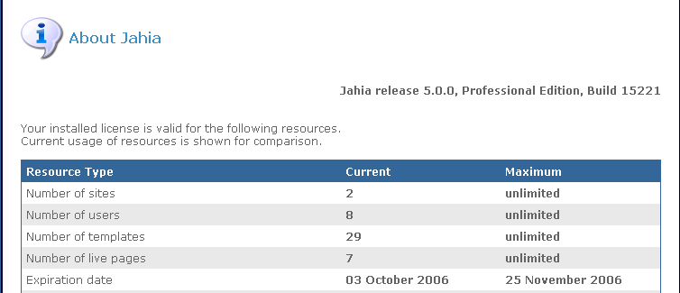

Figure 7-37: About Jahia

In this section you will find the Jahia build number. It’s important to specify it when you report a bug in our issue tracker.

2.10 Manage server permissions

As for the Manage site permissions, in this section you can allow power user to do all the actions available in the server settings menu.
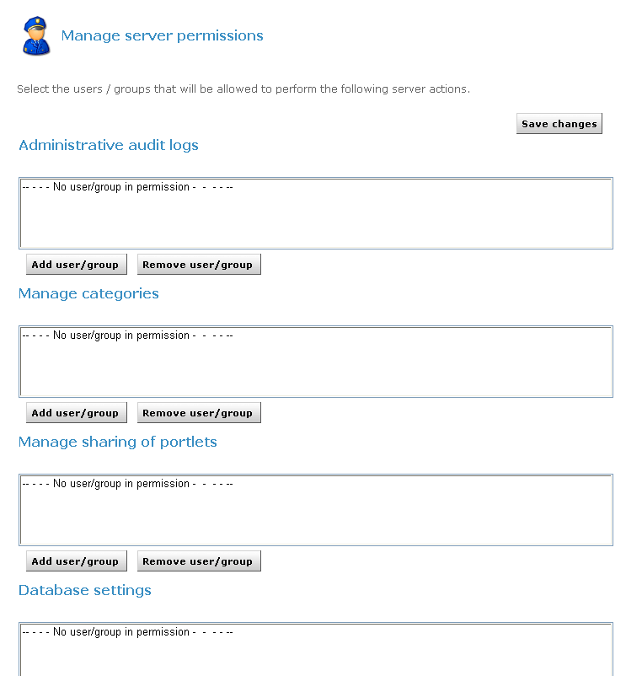

Figure 7-38: Manage server permissions

2.11 Statistics

After selected your site, you can displayed statistics on users, groups, templates, pages or most visited pages.

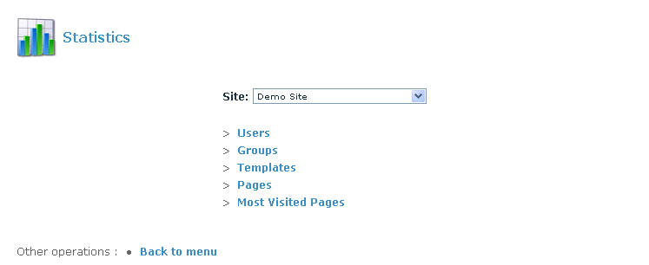

Figure 7-39: Statistics

Managing the jahia sites

In this chapter, you will see all the action a site administrator can make.

The administration panel is divided in 2 parts:
1. The Virtual Sites Administration lets you manage a specific virtual web site. Functions to manage users, groups, templates, user home pages or languages are available. This interface is available to all the Administrators of a site. The Super Administrator (Root) has also access to all the Virtual Sites Administration interfaces.
2. The Server Administration panel allows you to change all settings related to the Jahia Server configuration, as well as database settings. You can also manage the extract and deploy tools of Jahia and check the server status. Only the Root user can access this area.

Site Settings

Figure 3-1: Site settings
This screen includes all administration tools to manage one custom virtual site. The Super Administrator can see this panel for each virtual site by selecting any site in the drop-down list. The site administrator (siteadmin) has no access to the Server Administration Panel, he can only access to this screen and only for the virtual site(s) he is managing.

1.1 Page Settings

Figure 3-2: Page settings

Through this menu, you can switch templates for any page of your Jahia Portal. This allows you to change the layout of a given page by applying a new template to it. Please note that both templates should share common fields to be able to output the same data. Please refer to the Templates Guide for more details on how to build templates.
Just choose the page you want to “skin” and select the template you want to apply. Click on Save Changes to validate modifications.
If you choose a new template which doesn’t use any field of the current template, your data won’t be displayed, but they won’t be lost. Switch again to the first template to recover your original page layout and corresponding data.
Such an option can be useful to revert from a template producing errors to a known good template for a specific page of your site.

1.2 Manage users

Figure 3-3: Manage Users

This interface allows site administrators to manage the Jahia users available on the current virtual site. You can add, edit or delete users, as well as insert users in groups or move users between groups. Please note that the default Jahia Administrator user as well as the guest (anonymous) user can’t be deleted. In fact the Jahia Administrator and the Root user do not appear in the list of users as they automatically have full permissions on the site.
You can also browse, search and sort users from different sources. Right now users can be either stored directly in the Jahia system or authenticated against a third party LDAP server. To learn how to configure access to a LDAP server, please refer to the “Advanced Settings” chapter.
In case you have several hundred users, you can use the search field to retrieve specific users. Wildcards can be used, for example to search all users whose name begins with “s”. Just enter “s*” in the search field and click on search. You can also sort in ascending or descending order the list of users by provider or by username just by clicking the arrows icon above the users list.
To add a user, just click on Create new user, enter required information and click on OK. To edit the settings of a user, select it and click on Edit/View selected user properties.

If you want to use the e-mail alert feature of the workflow process, you need to specify the e-mail address of the user you are creating.

Through the “Edit user properties” menu, you can also set a homepage for a user. When this user logs in and if he selects “Jump to personal home page” in the drop-down list of the login window, he will automatically be redirected to the page defined in this menu. A link to his homepage can also be found in the top bar menu once the user has logged in.

Figure 3-4: Home Page Selection

Click twice on OK to validate.
If you want to delete a user, click on “Remove selected user”. He will also be removed from all pages where he had specific rights. Please note that you cannot remove a user stored in a LDAP server.

By clicking on Manage groups, you will be able to create or delete groups and move users between groups. See next paragraph for details.

1.3 Manage groups

Figure 3-5: Manage groups

Three groups exist by default in Jahia and cannot be removed:
- Administrators: all users that have complete administration rights on the whole virtual site.
- Users: all users (Jahia or LDAP users) are part of this group by default.
- Guest: this group represents all the possible anonymous and logged users (Group Users + anonymous user). As the anonymous user (guest user) is considered in Jahia as a standard automatically logged user, if you only grant access to a page to the guest user, other logged users will not have access to this page. You will then need to grant access to the full guest group which includes both logged and anonymous users.

To add or remove users from one of these groups, select a group and click on edit selected group. Select one user (or press the Ctrl key to choose multiple users) and click on remove members. If you want to add new users to the group, click on add members.

Figure 3-6: Add a new member to a group

If no users are displayed, press on search to display the full list of users. Select users and click on Ok to add them to the current group.
Two icons at the right of the panel allow you to ease selection in case you have many users:

: Select all users

: Invert selection

You can also copy groups and keep in the new group all users from the source group. For example, select group “users” and click on Copy selected group. Give the new group a name, i.e. “users_copy” and click on OK. You now have a second group containing the same members as the “users” group.

Currently, the groups of groups feature is not supported yet

1.4 Manage templates

Figure 3-7: Manage template

This panel allows you to manage the different templates which can be made available to users of Jahia. As with the portlets, you can decide whether you want automatic or manual deployment. Just click on Templates Management Options to select or unselect Automatic Deployment Mode and click on Save.

If you have packaged your set of templates in an .ear file, you can copy it to the following directory:

TOMCAT_HOME/webapps/jahia/WEB-INF/var/new_templates/ name_of_your_site

If the Automatic Deployment Mode is enabled, the new templates should be available after a few seconds. Otherwise click on Deploy new templates. You will need to refresh the page to see the updated list, or to go back to the menu and then open again the Manage templates panel.

Manual templates deployment
If you haven’t packaged your templates in an .EAR file, you can still deploy them by clicking on Manually add a new template.

Figure 3-8: Manage template deployment

As illustrated in the above screenshot, the folder containing the templates to be deployed must be located in the following directory:

TOMCAT_HOME/webapps/jahia/jsp/jahia/templates/name_of_your_site

For example, if you are currently managing the mycompany virtual site, you will need to copy your templates in the following directory:

TOMCAT_HOME/tomcat/webapps/jahia/jsp/jahia/templates/mycompany/

First enter the name of the template as it will appear in the template drop-down menu when you add a new page to your virtual site.
Then enter the directory name in which you copied your templates, relative to the path mentioned above. (i.e: mytemplates/).

Finally enter the name of the jsp file (i.e.: first_template.jsp).

Please note that directories and templates names are case sensitive

If the checkbox Available to users is not selected, the template will not appear in the list of available templates in the drop-down menu when you add a page to your virtual site.
When editing an already deployed template, the checkbox Is the default will specify that this template should be selected by default in the template selection drop-down menu of the “add page” interface.
Click on Save. The following message will be displayed if the template was deployed correctly:

The template was installed successfully

If you have an error message, please check that the file name is correct and that it is indeed present in the directory entered.

Templates Access Permissions
Thanks to the Access Control List (ACL) system in Jahia, you can also manage rights on templates to specify which user may have access to which templates.
Select a template and click on Edit. You can also double-click on the template name.

Figure 3-9: Edit template

Select the “Rights” section.

Figure 3-10: Template right management

By default every user has access to all templates, provided that he has sufficient rights to manage content and add pages on a section of the site. To remove access on the current template for a user or a group, click on “Add new users/groups...”. Choose all users/groups which should not have access to the current template and click on OK. Then select these users/groups and switch the “read” radio button from “Allow” to “Deny”. The “Write” and “Administration” radio button may be used in the future but have currently no effects.
Now the selected users/groups won’t be able to add pages based on this template, neither will they be able to switch the template of an existing page to this template.

1.5 Manage Search engine

Figure 3-11: Search engine indexing

Jahia uses the Jakarta Lucene technology from the Apache Foundation (http:// jakarta.apache.org/lucene) to index content. Lucene is a high-performance, full-featured text search engine which relies on an index file, and so minimize RAM usage.
Before being able to use the search engine in your site, you need to create the index file. Normally this file is automatically created when you create a new virtual site. You will also need to re-index the site after restoring a site backup or extraction. In all the other cases, the search index will be updated in real time when content is modified or added in the system. Click on Next step and OK to index your site. Once the process is completed you should have the following screen:

Figure 3-12: Indexing successful

As the index is stored in a file, you won’t need to re-create your index in case you need to shutdown and restart your Jahia server. You can also launch an optimization of the search index if you think it needs to be optimized.

Here is a summary of the syntax that can be used while doing a search. Detailed information of the syntax can be found in the “Live Site” chapter of the End User Guide or in the query syntax page of Jakarta Lucene (http://jakarta.apache.org/lucene/docs/queryparsersyntax.html).

Boolean operations:
Boolean operators allow terms to be combined through logic operators. The search engine supports AND, "+", OR, NOT and "-" as Boolean operators (Note: Boolean operators must be ALL CAPS).

Wildcards
The search engine supports single and multiple character wildcard searches.
To perform a single character wildcard search, use the "?" symbol.
To perform a multiple character wildcard search, use the "*" symbol.

The single character wildcard search looks for terms that match those with the single character replaced. Multiple character wildcard searches looks for 0 or more characters. You can also use the wildcard searches in the middle of a term.

Grouping
The search engine supports using parentheses to group clauses to form sub queries. This can be very useful if you want to control the Boolean logic for a query.

Fuzzy search
The search engine supports fuzzy searches based on the Levenshtein Distance, or Edit Distance algorithm. To do a fuzzy search use the tilde, "~", symbol at the end of a Single word Term.

Proximity search
The search engine supports finding words which are a within a specific distance away. To do a proximity search use the tilde, "~", symbol at the end of a Phrase.

Boosting a term
The search engine provides the relevance level of matching documents based on the terms found. To boost a term use the caret, "^", symbol with a boost factor (a number) at the end of the term you are searching. The higher the boost factor, the more relevant the term will be.

Detailed information and examples can be found in the End User Guide or in the query syntax page of Jakarta Lucene (http://jakarta.apache.org/lucene/docs/queryparsersyntax.html).

Although the “manage search engine” menu is available in the virtual site administration panel because there is one index per virtual site, you still need for the moment server administrator’s rights to be able to index a virtual site.

1.6 Manage Home Page Definitions

Figure 3-13: Home Page Definitions

You can set a list of Home page definition to be used as Home Pages for existing users/ groups. You can also define a Home Page which will be attributed to each new user/group at creation time.

To create a new home page definition, click on “Add”.

Figure 3-14: Add a new home page definition

Once you have entered a name and chosen an existing page for your home page definition, click on Save.

To define which home page definition will be used when creating a user or a group, click on Home pages general settings. You can use a different Home Page for users and for groups.

1.7 Manage languages

From this interface you can manage all parameters related to language for the current virtual site. The upper part of the panel displays all the languages currently configured. For each language, you can select 2 options:

- Active: if checked, this language will be available in the edition pop-up and users will be able to switch to this language. At least one language must be activated.

- Mandatory: if checked, you won’t be able to validate a page until content for all mandatory languages have been completed. For instance, if you add a new page but only entered a title in English when French is a mandatory language, you won’t be able to publish it in any languages. This prevents content from being published before it is available for all mandatory languages.

Figure 3-15: Manage language menu

For intranet or extranet purposes, you may often want to be able to display content to the user whatever the language he is currently browsing the site. For example, if you do not wish to have empty pages for languages where content is not available yet, you can activate the “mix languages when navigating site” option. This will use existing content of the other languages to fill in the blanks. You may, for instance, have some area with English content in the French part of a virtual site if this content is not yet available in the French language.

If you want to remove a language from a virtual site, just unselect the “Active” checkbox and click on “Save changes”.

To add a new language to the virtual site, select it from the list of available languages. You may notice that many languages are listed multiple times. In fact the list is based on “locale” or language for a region, so it does not only specifies a language, but also a region. Jahia will identify this “locale” setting of browsers, and can behave differently whether it identifies a French-configured browser from a Canadian user (“fr_CA”) or from a French user (fr_FR). If you wish to add the “generic” French language, just choose the “French (fr)” option.
Unless you plan to add some content specific to a country or region (like fr_CA or fr_FR), you should normally use the generic locale (fr) for a given language.
Click on the
icon to add the language to the list of configured languages.

Language mappings
The “language mappings” option is useful when you have created a site with two different locales for the same language. In for example you have both French-Canada (fr_CA) and French-France (fr_FR) locales configured on your site, you may want to specify which language will be displayed when a user with a generic French (fr) locale access your site.
Click on “edit language mappings” once you have added both fr_FR and fr_CA to choose which locale will be mapped to the fr locale.

To summarize, here is the normal behavior if you have the following configured languages and mapping:

Figure 3-16: Language configured

Figure 3-17: Language mapping

1.8 Manage distant site for auto export

Often site administrators need to separate the intranet environment from the Internet zone. However authors are also most of the time employees and publish content from within the intranet zone.

Thanks to this option, you can create your public web site within your private environment and replicate it on a distant Jahia server.

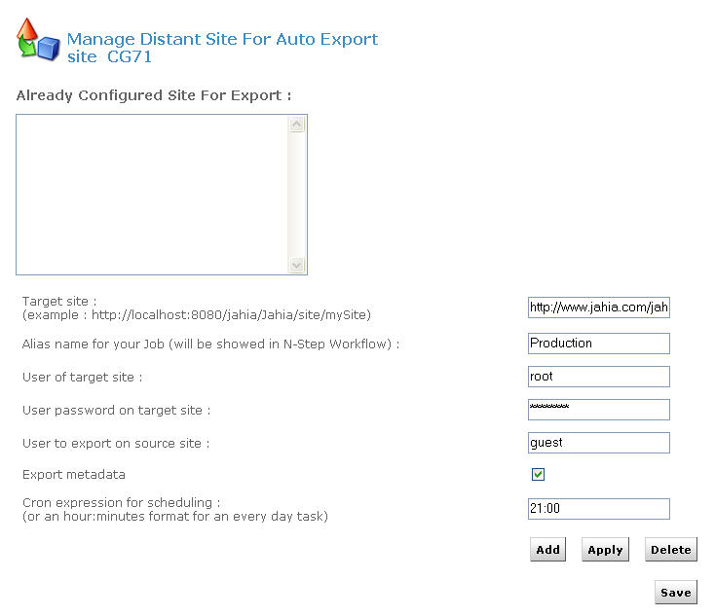

Figure 3-18: Auto Export

In order to avoid confidential and restricted information to be published on a distant public web site, only information available for the chosen user will be exported (by default the guest/anonymous user).

Jahia uses the cron syntax in order to let you select the frequency of your site replication. So you can decide to update your distant site once a week, once a day or once an hour.

Finally Jahia uses its internal XML import/export module in order to replicate the current web site.

1.9 Build clip portlet

HTML Clip Portlet

With this interface, you can easily extract train schedules, the latest stock quotes or weather information from any existing sites and generate a dynamic portlet of it.

It even manages authentification in order to access to restricted web sites.

The Webclipbuilder is wizard with 5 steps.

Configuration: set parameter (optional step)
This step allows you to define advanced parameters for the navigation module of the portlet.
Parameters definition can be find by clicking on the Help link.

Figure 3-19: HTML Portlet Builder - Set parameter

You just need to click on the Save Default button to save the configuration and you will have access to the ADD button.

Figure 3-20: HTML Portlet Builder – Add clipper

To create a new clipper, click on the Add button.

Step 1: Clipper Description

In this step you will define the name, title, description and the target URL. In our example we will create a clipper which present you CFF timetable for Geneva Lausanne.

Figure 3-21: HTML Portlet builder – Description

Step 2: Clipper Recording

This part is the most important part of the clipper creation. You will be able to specify the page sequences to access to your final result.
To record a sequence, click on the Start button, and navigate normally until you access the desired page, then click on the Next step button.
Be careful; don’t click on link contained on iframe.

Figure 3-22: HTML Portlet builder - Browse

Step 3: Edit parameter and cut

Depending of the clipper you created, you might need parameters.
Here are the properties you can define:

Mapping: This will be the name of the parameter displayed in the clipper
Used value: Display the actual value

Use as default value: If you want to used the actual value by default
Visibility: If you want to display the parameter to the user, in our example we select the Departure and the Arrival parameters to be visible.
Automatic type Update: If you want to replace the default value by the one generated by the server. In our case we set the Journey Date to be automatically updated.

Figure 3-23: HTML Portlet builder – Edit parameter

You need now to cut your clip to select the part you want to display in the portlet.

Figure 3-24: HTML Portlet builder – Select part

With the Chew clipping method, you need to select the tag which will be used to cut the selection.
You can have details about the different filter by clicking on the Help link.

Step 4: Load your clipper

To test your clipper, you just need to load it
In our example we can see the 2 parameters we define as visible and their default value.

Figure 3-25: HTML Portlet builder – Load

By clicking on the GO button, you will preview the final result.

Figure 3-26: HTML Portlet builder – Preview

The last step is now to deploy it, and the portlet will be available in the list when you will add portlet.

SQL Clip Portlet

This type of portlet allows you to display any content of a database table.

Figure 3-27: SQL Portlet builder

You need to provide the data source of your SQL DB, your SQL request and Jahia will generate a dynamic portlet with the results set.
Users will be able to sort, extract or filter the result of this SQL query.

1.8 Manage site permissions

In this area, you can delegate accesses to all the site menu features to any power users.
You can grant custom permissions for all the actions available in the edition pop-up windows or the edition menus.

As you can see in the figure, you can specify a group of user for each action available in :
The Administration panel
The Edit menu
The Tools menu
A list of actions define in the Actions tab
And the edition of the language for the author.

Figure 3-28: Manage site permissions

Server settings
Let’s continue with the Server Administration Panel.

Figure 3-29: Server Administration

2.1 Virtual site management

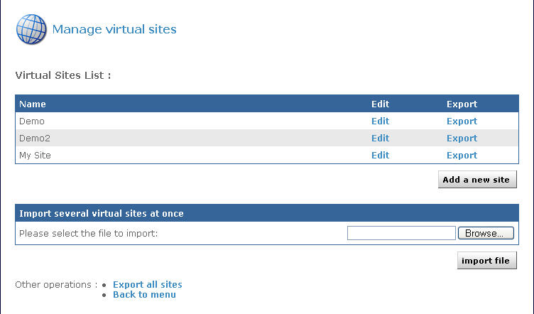

Figure 3-30: Virtual Site menu

You can create multiple virtual web sites on top of one Jahia physical server, each with its own set of templates, components, users and groups. For example, you can have one website accessible through the url www.first_domain.com and another one through www.second_domain.com, both running on the same Jahia server.

The default site created during installation appears in the virtual sites list as “My Jahia Site”. To add a new virtual site, click on Add Site. If you want to edit settings for an existing virtual site, click on the Edit button.

Figure 3-31: New virtual site properties

First, enter a site title. The site title will appear on the virtual site list.
Then enter a site server name; this indicates the name of the server on which Jahia runs. You can specify a URL for the site server name, for example www.mycompany.com and if your DNS is correctly configured, you will be able to access this virtual site by directly typing this url. Remember that the default port to access Jahia is 8080, so to call this specific virtual site, you will have to enter something like:

http://www.mycompany.com:8080/jahia

You also need to enter a site key. This is a keyword that will be used in the url to access this specific virtual site. For example, if you use localhost address and want to access a virtual site with the mycompany site, the url will be something like:

http://localhost:8080/jahia/Jahia/site/mycompany/

You can note that if you are using a fully qualified name to access your virtual site (i.e. www.mywebsite.com), you don’t need to use the site key in the URL.

Select then the first checkbox if you would like to make this virtual site the default site. It means that if you type the base url of jahia (i.e http://localhost:8080/jahia/ Jahia), you will be redirected to the home page of this particular site.

You then need to define the administrator account for this site. The site administrator will be able to manage users, groups, templates and components for his/her site but won’t be able to access to the Server Administration (Root only). You have the choice of creating a new user for this role or to select the administrator of another already existing virtual site.
Then click on Next step.
If you selected New User, you will need to enter requested information for the site administrator account
If you selected the second option, you will need to choose the web site from which you want to select the administrator, and then select the administrator.

Once you have created a new administrator for the virtual site (or selected one from another virtual site), you need to choose the default set of templates that will be used.

When you install Jahia 5, 2 set of templates are provided: Corporate portal templates v2 and Corporate portal. You can add a new set of templates by placing the templates jar in \tomcat\webapps\jahia\WEB-INF\var\shared_templates, it will be deployed automatically after you restart Tomcat.

Figure 3-32: Template set selection

You can still replace afterward the templates by your own once the virtual site is created.

Edit site
In this menu you can change the site title as well as the site server name. It is also through this menu that you can delete an existing site. Be aware that when deleting a site, you will also suppress all users and groups related to this site, as well as all templates, applications and file repository of the virtual site. If you want to preserve one of these objects, you can uncheck the corresponding box before you confirm the deletion of the site.

2.2 Manage categories

Content inside Jahia can be categorized for easy retrieval. It means that you can create a series of categories and sub-categories and Jahia objects can be later on associated to one or many of them. Pages, containers lists and containers can be categorized. You can then for example recover in a Jahia template all objects belonging to one category or all categories on object is associated with.
You could for instance recover on a departmental home page all the news published throughout the site which have been also associated to the category of this department. You can even re-use content from other virtual site on the same jahia server through the category mechanism, as content categorized can be retrieved throughout all virtual sites.

Figure 3-33: List of already created categories

For each category, you can define one or many associated properties. For instance, you can define as a property the departmental home page associated to the category, a description of the category or any other associated property. The properties can of course also be retrieved inside Jahia templates. A sample categorie browsing template is provided with the default “corporate portal” templates packaged with Jahia.
To add a new category, just select the parent category and click on “” the add button.

By default the categories can’t be seen by the guest user, so you need to go to the right menu in the Data section, add the guest user and give him the permissions to read the categories.

Figure 3-34: Adding a category

Enter the category key (a unique identifier for each category throughout all virtual sites), the category title for each language available on your Jahia server (if no title is entered, the category key will be used as title). If needed, enter then a property name and value and click on the Apply button. You can enter as many properties as needed.
Now when you update a page, a containers list or a container on your web site, click on the “Metadata” section and you should see the list of categories you just created under “Categories” link.

2.3 Server settings

From here you can changes the mail settings that were defined during the Jahia Configuration Wizard.

Figure 3-35: Server settings

In case you want to use the e-mail notification feature to be warned if errors occur, please enter your mail server address (SMTP server), as well as your e-mail address and the e-mail address from where the notification is sent. Then select the event notification level, from None to Paranoid. These event notifications will help you solve problems when you are testing newly designed templates. Make sure the SMTP server you are using to send notifications is configured to accept mail from the server running Jahia without needing SMTP authentication.

2.4 Manage portlets

Figure 3-36: Manage portlets

Portlets (or web applications) can be easily deployed and used within Jahia. A dozen of web applications are already provided with the default Jahia installation package, ranging from a file manager to a time reporting or a forum. If your Jahia edition is not prepackaged with these applications, you may download them directly from the Jahia.org web site.

You can also develop new web applications. Please refer to the Jahia WebApps Guide to learn how to develop new applications or adapt your already existing Java applications to work within Jahia.

To deploy automatically a new component, all you need to do is copy the .EAR or .WAR file to the following directory:

TOMCAT_HOME/webapps/jahia/WEB-INF/var/new_webapps/

After a few seconds, Jahia will automatically deploy the component. Just return to the Manage portlets panel to see the new application
If you prefer not to have your portlets automatically deployed, enter the Portlets Management Options, unselect the Automatic deployment Mode box and click on Save.

To manually deploy new applications, either click on Deploy new portlets, to have Jahia search in the new_webapps directory for new portlets, or on Manually add a new portlet to specify the path to the new applications you want to deploy as well as its full name (i.e: /foo/bar/apps.ear on Unix or c:\foo\bar\apps.ear on Windows). If your application is not contained in a .ear or .war file (compressed file containing all files needed for the application), you can also specify a path to the directory where the webapps resides (i.e /TOMCAT_HOME/webapps/mywebapp/).

2.5 Administrative audit logs

Figure 3-37: Administrative audit logs

Jahia keeps track of all manipulations made on the site (log in, log out, add, delete,...) with date, time and user who performed the action.

By default, Jahia keeps the last 500 entries. To display the audit logs, click on view logs.

Figure 3-38: View logs

The audit log can be filtered or directly exported in various different formats.

2.6 Edit super Admin properties

You can at any time change settings (name, password, e-mail address,...) for the Jahia Super Administrator.

Figure 3-39: Super administrator properties

Just modify the information and click on OK.

2.7 HTML Checks and Validation

The HTML Checks and Validation menu allows you to customize internal HTML code verification (internal links cross checking, WAI, …) which Jahia can optionally perform on rich elements.

Display HTML Editor List
Through this panel, you can display the HTML editors which are configured to be used inside Jahia. Two editors are available by default: a FCK Editor which works with most internet browsers and a Simple Text.

Figure 3-40: Registered HTML Editor

A configuration file exists, which defines which editor should be available as well as the display order of the editors and the default editor. This file, htmleditors_config.xml, is located in the following directory:

TOMCAT_HOME/webapps/jahia/WEB-INF/etc/htmleditors

Changes to this file can be reloaded without restarting Jahia, by clicking on the “Reload Html editors configuration file from disk” link.
To learn how to change the order in which the various HTML editors are displayed in the Jahia edition GUI and how to add other new editors, please check the “FAQ” chapter.

Markups to remove when parsing text content

In this section, you can choose which HTML tag should be automatically removed from the rich texts entered by editors.
For example, if you want to remove the <FONT> tag, you just need to Add a new markup

Figure 3-41: Add a markup

Manage site settings

Figure 3-42: Manage sites setting

You can access here to a by site summary of all activated options performed on rich text objects.
The HTML Cleanup option will allow you to define if rich text elements will be parsed and automatically corrected in case of HTML syntax errors.
The Markup Filtering option allows you to automatically remove certain tags entered by the editors.
The URL integrity check will block validation of an element until cross-references pointing to this element are not connected first in order to limit possible 403 or 404 errors in live mode.
And finally the WAI Compliance option will force WAI Level 1 compatibility while editing a rich text element.

2.8 Server and cache status

The server status informs you about the state of Jahia’s various cache systems, as well as memory used and database connection pool. This can be very helpful to help detect potential problems. You may also use this interface to flush one or several Jahia back-end caches.

Figure 3-43: Jahia Cache status and flush

Jahia automatically caches already accessed HTML pages in memory in order to improve the response time for the next users. Access to pages already available in the HTML cache proxy can be between 10 and 20 times faster than non-cached pages as it avoids any connection to the database or any other time and CPU intensive java operations. Indeed Jahia just needs to output a pre-existing copy of the HTML page rather than dynamically assembling all the required content objects.

Of course, each time the content of a page is updated, the copy of the concerned pages in memory will be automatically flushed by the system. For example if you change the title of the home page, all the pages of your site will be automatically flushed as all the navigation menu will then become obsolete.

By default, the HTML cache (as well as other back end caches) is not limited in size. As Jahia stores one copy of the HTML page per logged user (each user may have different permissions and then a different HTML view of the same web page), this may use quite a lot of memory according to the size of your site.

2.9 About Jahia

Figure 3-44: About Jahia

In this section you will find the Jahia build number. It’s important to specify it when you report a bug in our issue tracker.

2.10 Manage server permissions

As for the Manage site permissions, in this section you can allow power user to do all the actions available in the server settings menu.

Figure 3-45: Manage server permissions

2.11 Statistics

After selected your site, you can displayed statistics on users, groups, templates, pages or most visited pages.

Figure 3-46: Statistics

